April 2001
Not to be modified w/o approval of D. M. LaBorde
TWEAKWinVE (TWKWVE)
Version 1.0

Preface
I strongly suggest first time readers review this (first) page before proceeding.

TWEAKWinVE (Tweak Windows for Video Editing) was developed for two Microsoft Windows Operating Systems (Windows Me ® and Windows 2000 ®). The document is a separate file for each operating system. I have tried to structure this in two formats : 1.) Discussion Detailed Section - Each tweak is discussed in detail. How and/or why the tweak works followed by step-by-step “how-to-do”. Many include screen captures for reference. 2.) Quick Reference Table - Developed for fast review and rundown. Those with OS experience can quickly “rundown” the list and make the appropriate checks & changes. The table is setup with a column for entry of current values should the reader want to keep track of changes made.

The concept is that a number of small changes can add up to a significant impact on PC performance. Many of the “tweaks” singularly do not represent a noticeable difference but added together they do make a significant difference. There are, however, a few listed that will make a large impact by itself. After the “tweaks” were made; the “Available System Resources” for Win Me was 99 % (just after boot-up) - Win 2000 had 18 processes running & 97 % available memory.. Both operating systems were put through paces with typical editing / capturing functions - rendering and “RealTime” transitions/filters. Both were VERY STABLE. Interestingly, the WinME seem to function just as well as the Win 2000 i.e. very little difference in response time when changing RT screens, etc,. Testing time was limited so long editing segments were not done for all test. The NT coded system would be expected to (possibly) produce more stability. That was not necessarily experienced or given the opportunity to do so.

Each Tweak was tested to determine the impact with regards to video editing not other types of PC usage (gaming, etc.). All test were done using the Matrox RT-2000 editing system with Premiere 6.0. This system can produce high processing loads on the operating system and it makes an excellent selection to troubleshoot (replicate high-end use). The computer system used for testing could be considered medium to high-end for 2 Qtr 2001. It utilizes a PIII – 800 Processor and has 512 megs of SDRAM 133. System drive was purposely set on IDE ATA-33 (UMDA mode) – slower swapfile (pagefile) response, etc.. The Audio HD was a separate UMDA-66. Video drives were on an ATA-66 RAID device. The OS hard drives were utilized in a portable caddy so that each could be swapped and the same video scenes tested – edited, etc.

The Internet is riddled with information of “tweaks” and or fixes. Many of these are unproven, dangerous and/or not applicable to editing processing power. I have gleaned through many of these and include those worthy. This document would become too large and impractical to list all failures or “snake-oil settings or “tweak utilities”.

"The difference between theory and real life is that - in theory, there is no difference between theory and real life, but in real life, there is a difference." Although all settings have been tested; this author cannot be responsible for entry errors by the individual and/or the “state” that a problematic system may already be in (void of permanent recovery). It would be wise to make a recovery disk or back-up for system restore. No money is solicited just pass on this information to help others experience the exciting field of videography. For new findings and/or problems found in current settings (for future updates) send to : dlaborde@shabakah.net.sa
“Tweaking” steps are why some systems seem to run forever, are rock solid, and suffer none or trivial resource leaks; while others are memory sieves that have to be rebooted on a regular and routine basis. You can take time to read this and make the adjustments or later make time to troubleshoot system freezes, crashes and loose critical editing time.

Windows ME TWEAKS
Not to be modified w/o approval of D. M. LaBorde

Version 1.0

I have read and/or heard analysis by many videographers claiming Windows Me was problematic and slower than Win 98SE. Typically, vague results or just blanket remarks were made with no hard conclusive evidence given. I have analyzed and tweaked a ME system for video editing. From my test; I find that it can be as or more responsive and stable than my experience with Win 98 / SE. This is especially true with regards to multi-media type programs. I do believe some of the negative information given was due to problematic setups and/or drivers in the early months after introduction. I did, however, find that more tweaking was needed to gain the desired response for VE. Video Editing manufactures (such as Matrox) are moving support to Win ME. Hence my tweaks and analysis are with ME. Most of these are transferable to Win98 systems but not guaranteed to be as effective. Many of the tweaks given are similar to those used in Win 98 editing days, however, some values (formula) settings have changed so experienced readers are encouraged to read all areas even those they are familiar with.

Many of the “tweaks” given will initiate a message that a shutdown is required for the change to take place. It is suggested that the viewer not cancel shutdown for more than 2 or 3 changes before initiating a reboot. All the tweaks have been tested but any given condition (registry settings and equipment drivers) can vary enough (on an individual’s machine) that a conflict is possible though not likely. Should one occur, a small number of changes; can make troubleshooting much easier. If equipment / registry conflicts occur; a reboot into safe mode should allow one to return to previous conditions, etc.
System Performance and Preparation (“Success is in the details”)
The more RAM you have; the better. With today's memory prices you might want to optimize your current memory system. Video Editing (VE) users should have at least 128 MB RAM to get decent performance in Win ME. My test have shown that Premiere 6.0 responds much better with at least 384 MB of RAM but 128 MB (with proper tweaks) is achievable and effective in RealTime. The latest DirectX 8.0a and 8.0bda patch were used and very responsive / stable.
Before doing any significant a number of “tweaks” it is advisable (and actually beneficial to performance success) to do a number of preparatory items. This places the OS in a more responsive- receptive mode for “tweaking”.
- Do a disk scan and repair to clear up bad sectors.
- Do a disk defrag to compact and un-fragment data.
- Scan registry for fragments and compact (compress). To do this safely and effectively programs such as SystemSuite or Easy Cleaner or Norton Utilities. They are much better than tools in Windows. Compressing removes any unused space, making the registry file smaller & faster.
The “TWEAKS”
- Virtual memory – Windows uses a dynamic virtual memory manager to handle Swapfile duties. It provides more memory to applications than is physically present in the computer RAM (It uses hard disk space to simulate RAM). The amount of RAM in the computer plus the size of the “Swapfile” equals the total virtual memory size. Windows uses a dynamic Swapfile that remains at a size of 0K until it is needed. The Swapfile can grow to use all the available space on the hard disk if it is necessary. This is the default setting for the “swapfile”. With Video Editing it is more efficient to set this yourself rather than let Windows dynamically manage it. When Win manages the file it can increase or shrink and eventually gets distributed (fragmented) over the disk taking more time to access.
Calculating Virtual memory - Before you can set your Virtual memory you’ll want to calculate what to set it too. Some recommend using a general formula - Physical RAM X 2. This can, however, be incorrect. Using that formula, a person with 64 MB RAM should set 128MB, while a person with 128MB RAM should set 256MB. Clearly the person with little RAM needs a greater amount of Virtual memory than the person with a lot of RAM. I suggest RAM X 2.5 for systems with 256 MB or less and RAM X 2 for those above 256 MB. Selecting a fixed minimum swapfile will drastically reduce the thrashing your hard disk that it takes from 98/ME's “dynapage”
1. Right click on My computer & select Properties. Select the Performance tab.
2. Select Virtual memory. Choose Let me specify my own virtual memory setting.
  - Set it as shown below (substituting in your own values of course). The values shown below are for a system with 512 MB of physical RAM.
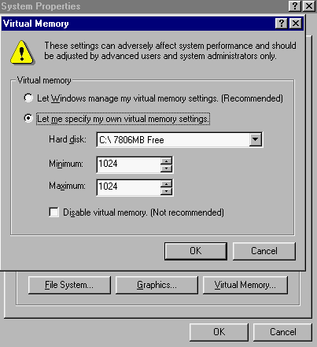
Once you have set your Virtual memory size you can further optimize it. The Swapfile is best placed on the outer edge of the hard disk it is located on. Windows 9x\Me Disk Defragmenter will not do this. You’ll need a disk defragmenter like Norton Speed Disk or McAfee Nut’s & Bolts to do so.
I do not recommended that you put your Swapfile onto a separate partition of your system drive as this will increase the time to access it & increases hard drive head movement as well. Instead, it is recommended that it be placed on the most used partition of the least used drive. This will mean the C:\ drive where Windows is installed for users with a single hard drive. If you have another hard drive installed you should use that instead. To change where the Swapfile is located, change the Hard disk location when setting Virtual memory (see display above). Do not place the swap file on your video disk as high editing and capture activity can cause conflicts / delays. Ideally you would want to place your Swapfile onto a separate hard drive, on a separate IDE channel (if possible do not put 2 high activity hard drives on the same IDE channel). I currently have mine on the system drive. Again, the swapfile should go onto the outer edge of that hard drive using a Utility Program like Norton or Nut’s & Bolts, etc

Virtual Memory (continued)
Save the changes you have made & reboot for these settings to take effect. When you change to select your own settings versus letting Win do it you will get an alarm just acknowledge and proceed.
One added note - during certain encoding processes i.e. encoding to mpeg-1 or 2 with software programs like Tmpgenc / Panasonic you may receive an out of memory error while doing a long segment coding. Set your MAX virtual memory setting to Drive size (MB’s) and than reset to normal after the encoding process.
2.) Hard Drive Service - The Swapfile exists on your hard drive and this is much slower than using RAM. So speeding up your hard drive can improve Swapfile performance a lot. Although more RAM is highly recommended, having a faster hard drive will aide. Make sure you regularly run Scandisk to fix any errors/ sectors on the hard drive
System Properties contains important settings which are used to improve hard drive performance and for troubleshooting purposes – hence it is in the troubleshooting tab.
Right click on My Computer, select Properties. Select the Performance tab. Now hit the File system button. Go to the Troubleshooting tab.
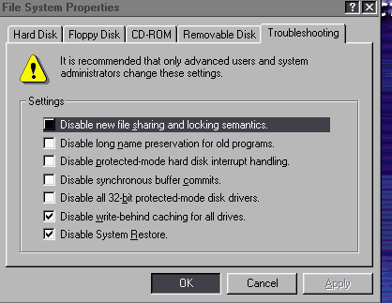
Disable new file sharing & locking semantics. This setting controls file-locking mechanisms in Windows. Tick (Disabled) this setting if you are currently experiencing problems with certain programs. However, it should be used as a last resort - your system will perform optimally with this setting “Unticked” (Enabled).
Disable write-behind caching for all drives. This setting tells the computer to cache all disk writing operations to that particular drive. Basically, this means that a certain amount of what is being written to the disk is actually being stored in the RAM and isn't written to the disk until either the cache starts overflowing (in which case it starts writing from the bottom of the cache) or the computer is shut down. Enabling this setting generally increases performance but in intensive editing mode and real-time operation RAM can become overloaded and also fragmented to actually reduce performance. Leave it ticked (disable write-behind) unless have large amounts of RAM and then even do high use (intensive editing test) to verify effectiveness.
Disable System Restore (Windows Millennium only). Ticking this setting will semi-disable Windows ME’s system restore capability. It is (semi) in it still replaces/rebuilds some files, e.g. autoexec.bat. The benefit of Ticking this setting is that it will lessen the amount of hard drive activity used to build System Restore files. This will improve editing system performance significantly.
3.) Vcache
By default Windows will determine these settings based on RAM installed (the Min/MaxFileCache). With Video Editing is better to set Vcache settings yourself. Vcache is limited to a maximum cache size of 800 MB – this really shouldn’t matter to anyone but those with excessive amounts of RAM (Greater than 512MB). On such high RAM systems not limiting the Vcache has been known to cause problems).
Click on Start, Run. Type in system.ini & hit Enter. Scroll down to the [vcache] section. Under that heading Add/Edit the following lines :
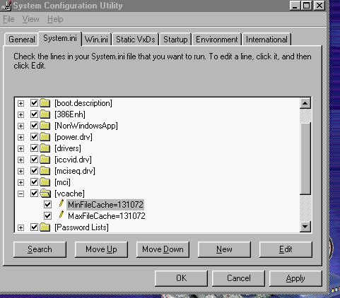
MinFileCache= sets the Minimum disk cache (in KB’s) on your system. This setting directly affects the physical RAM you can use on your machine, the higher you set it the less RAM will be available to applications. I recommend setting this to 1/8 your RAM X 1024 for 128 MB of physical RAM or less. Some suggest ¼ but this impacts performance with low levels of RAM. If you have more than 128 MB then using ¼ is acceptable. 128MB = 16384 setting. If you are missing this entry hit New button - type “MinFileCache=” (without quotations) and numeric value after the equal sign.
MaxFileCache= sets the Maximum disk cache (in KB’s) for your system. This setting directly affects the physical RAM you can use on your machine, the higher you set it the less RAM will be available to applications. I’d recommend setting this to 1/4 your RAM X 1024 , i.e. Double the MinFileCache (if using 1/8). Eg. 128 MB = 32768. If you are missing this entry type “MaxFileCache=” (without quotations) and numeric value after the equal sign. The visual screen capture was on a system with 512 MB of physical RAM.
Save and reboot. It may be worthwhile testing on different motherboards although the recommendations given above is what has worked best in tests.
There is another entry you can post in vcache; this is Chunksize. Chunksize=x. Chunksize can effect performance. Vcache is a single block of memory that is divided into chunks. If the Chunksize is too small it will occupy to many chunks & when set too
large it will occupy too few chunks. A program can have more than one chunk, but if it doesn't divide evenly into the size of the chunk, some RAM goes unused (i.e. is fragmented). On one hand, having a smaller chunk size allows for less wasted RAM in the vcache. On the other hand, a larger chunk size increases the access speed for the vcache. Common values are 128, 256, 512, 1024, and 2048 . The rule of thumb is, if you have any newer monster multi-GigaByte size hard disk, you may want to set this value to "high": 2048. The ideal value will lie in between two extremes. x represents a numeric value that is a multiple of 512, e.g. 512, 1024 & so on. Depending on your Min/MaxFileCache settings a good starting value for x would be 512 or 1024. Default in the registry (void of actual entry line in Sys.ini is 512). If after all tweaks you still find the system sluggage, unstable, dropped frames and/or poor sync try 1024 up to 2048.
4.) [386Enh Settings] – In system.ini TAB
Add the line ConservativeSwapfileUsage=1 This can significantly reduce Virtual memory use - it makes Windows use RAM before the (slow hard drive) Swapfile. This setting will tell Windows ME not to use the swap file at all until all of the RAM is used. After all of the RAM is used up, the computer will push most of the infrequently used data to the swap file so this is a very good adjustment (“tweak”). This is particularly beneficial for those with 256MB RAM or more. While in the [386Enh] section, add another line; DMABufferSize=64 to tweak DMA performance. This will conserve at least 64KB of memory to DMA (direct memory access) to reinsure that your DMA devices always have enough memory allocated. Note that this tweak should only be used if you have one or more DMA enabled devices on your system. Also add a line PageBuffers=32 This setting tells the computer to dedicate a certain amount of RAM to buffer the hard drive rather than allowing the operating system to dynamically handle the buffer. Windows dynamic handling of most memory issues is very inefficient, due to the large difference Windows sets between minimum and maximum values. 32 is the highest setting the operating system allows, so it is recommended that you use this value. LocalLoadHigh=1 This setting tells the operating system to load its local drivers into upper memory by default as opposed to trying to squeeze them into conventional memory. WARNING : The LocalLoad... tweak is only good if you have less than 128MB of RAM, but may actually hinder performance for those with 128MB or more . Exit Re-boot.
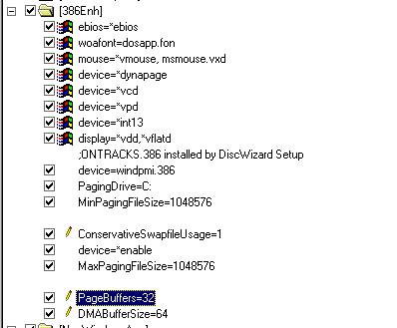

5.) Computer Role setting and Performance
These next 2 settings should be set in accordance with the “Typical role of this computer” setting (Right click on My Computer select Properties. select the Performance tab then the File system button). With the default selections Network server is the best recommended choice for video editing. Network server role places registry settings for high disk activity (which is what editing involves). Network Server caches 64 directory paths and 2729 filenames, and takes up 16K doing it. The "Desktop" setting caches 32 paths and 677 filenames, and takes 8K. The extra 8K is well worth the file system boost.
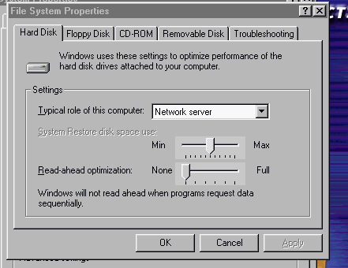
Set Read-ahead optimization to None. The slider setting changes the amount of RAM used for read-ahead optimization. Basically, Windows stores data temporarily to RAM versus your HD, since access to data stored in RAM is faster than access to data stored on your HD. Changing the "Read-Ahead Optimization" setting to "None" will, however, prevent block-size chunks of data (in the range of 1-2K) from being cached. Retrieving and reading this cached information interferes with high data rate playback. Selecting to None option causes the disk cache to flush continually. If you have problems with “realtime” transitions and/or drop frames in Premiere or av sync in capture. This is usually due to poor disk burst activity - setting to full will help. If have RAM > 128 MB try set to Full or 50 %.
6.) System Configuration Utility
The Windows Me version of msconfig differs in many ways to the Windows 9x version. With Windows Me there comes an extremely useful System Configuration Utility. This displays program/utilities running at Startup & gives you control over other aspects of the system itself. Click on Start > Run, type in msconfig & hit Enter. This will load the System Configuration Utility.

See Display next page

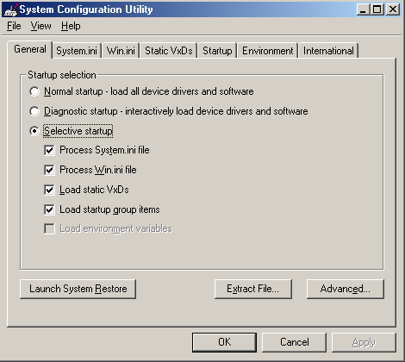
In the General tab you should select Selective startup as your Startup selection & “Untick” the Load environmental variables setting. This will give both optimal boot time & system performance. Now select the Startup tab.
This tab displays a list of all programs that are loaded upon system start-up. The items which are Ticked are actually being loaded upon Start-up. To disable an item from being loaded at Startup simply Untick it. The programs are typically called TSR – Terminate and Stay Resident. Now which to leave ticked……..
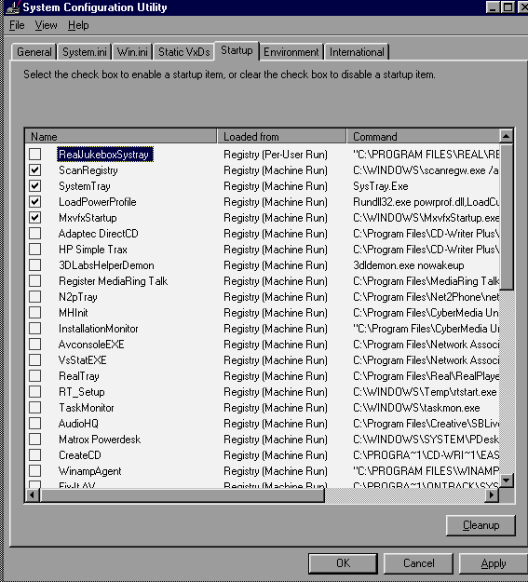

TSR programs load instructions into memory that shouldn’t be there for high intensive operation such as video editing. There are, however, a few that should be left in the background.
1. For System Stability you should leave the Scanreg entry “Ticked”, this makes backups of the System registry & should anything go wrong it will restore you system registry to a point upon which your system last booted normally.
2. “Untick” Findfast (If you have it). Findfast is a Microsoft a utility included with Microsoft Office applications that builds indexes to speed up finding documents from the Open dialog box in any Microsoft Office program & from Microsoft Outlook. However building these indexes can consume a lot of system resources while they are being updated & such. This feature is of little use to anyone as a result. Make sure you remove.
3. Leave System Tray and Load Power Profile “Ticked” – one or both may show up more than once and that’s OK.
- If using the Matrox RT-2000/2500 the. MxvfxStartup MUST be “Ticked” are the Card will not initiate.
- “Untick” all others – hit OK and close – reboot for changes to take effect.
7.) DMA mode for Hard Drives
Be sure to enable DMA/UDMA support on your hard drives. Right click on My Computer, select Properties. Select the Device Manager tab. Open Disk Drives, then you particular Hard Drive(s). Select the Settings tab.
Tick the DMA box to enable DMA support. By default this will be enabled in Windows 98/Millennium if available. In the BIOS you should also ensure you have your hard drive setup correctly to use the fastest transfer mode that’s supported on the hard drive. Check your BIOS to insure UMDA is properly identified. Click Ok & reboot your system for the changes to take effect. Also select DMA for CD/DVD drives,ertc.
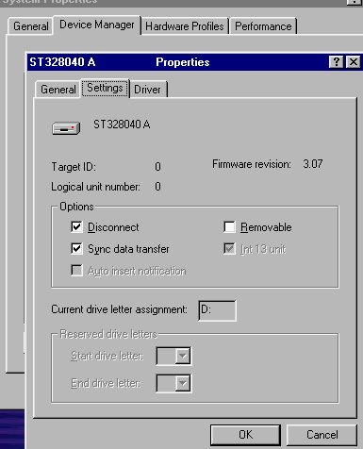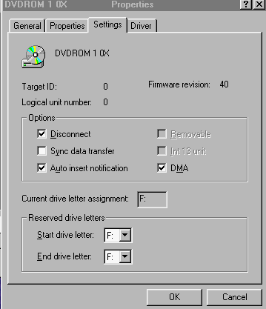

PIO mode data transfer rates are slower than DMA/UDMA transfer rates & the Swapfile benefits from a faster data transfer rate, assuming the hard drive supports it. Remember the Swapfile is located on your hard drive too; the faster the data transfer rates are, the faster your Swapfile is. A typical machine today will use 40% of the CPU doing hard drive transfers in PIO mode and use only 25% of the CPU doing hard drive transfers in DMA mode. Some of the newer Hard Drives & MOBO have automatic detection systems and actual DMA settings may not show up in the GUI for a particular driver although it is set so. You can insure DMA is selected by making an entry in the registry
Enabling DMA enter the below info into the Registry:
HKEY_LOCAL_MACHINE\Enum\ESDI\
"DMACurrentlyUsed"=hex:01
Note: 01 enables DMA, 00 disables Save and reboot.

8.) Optimizing File System Performance
Optimize file system performance | 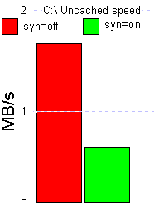
Increasing File System Access Times
- Double-click on My Computer, select Properties
- Click on the Performance tab
- Click on the File System button, and select the Troubleshooting tab
- Select: Disable Synchronous Buffer Commits
- Click Apply\Ok (requires a restart)
You should use this option only if you have a stable system! This option was added to allow adequate performance of a defective database application that used the file commit API incorrectly and excessively.
8.a.) Because Windows ME relies heavily on keeping your drive optimized (so that files are not broken up across non sequential clusters on your drive), you can reduce the amount of fragmentation that occurs by increasing the size of free space that Windows ME searches for before using that space to store files. This should reduce the amount of time that the Maintenance Wizard and the Scheduled Tasks have to take when tuning up your machine. The default size searched for is 512Kb, but if you have a drive plenty of space, you can increase this by changing a key in the Registry. If after all the “Tweaks” outlined here have been done and you are still a heavy load on your system go into Regedit :
HKEY_LOCAL_MACHINE\System\CurrentControlSet\Control\File System
- Right click and enter a new DWORD value. Enter the name:
ContigFileAllocSize
- Then enter a value of: 400 (Hex) for 1Mb.
This will mean that a lot of space is ignored on your drive until it is de-fragmented, which Windows 98/ME will have been set up to do automatically in the Maintenance Wizard and keeps from splitting large files are not split. I have not tried this one as have had no reason to so far but reliable sources indicate effective and safe.
9.) Small but Useful Adjustments / “Tweaks” – “Small Things Add-up”
A.) This is one of those tweaks that everyone does sooner or later as having a sound every time you click on the mouse gets extremely annoying and this also affects memory. In ME, instead of having a separate Sounds applet in the Control Panel, it is included in the Multimedia applet (duly renamed Sounds and Multimedia…). Just go into the Sounds section and select "No Sounds" from the drop-down menu then Click+apply.
B.) To speed things up a bit when you are working with windows, go into the Display applet and go over to the effects tab. Under visual effects, disable everything except "Show icons using all possible colors." This will speed up menus, moving windows around, and a few other things as well.

C.) Open My Computer, select View, then Folder Options. Here you can modify how your Windows desktop appears & how you can open folders. By default Windows 98 uses a slow, resource intensive method. You’ll want to change that of course.
Select Custom then the Settings button.
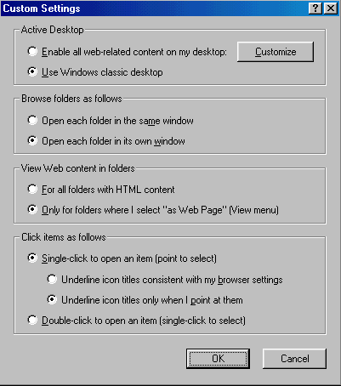
The settings pictured above will give you the fastest drawing of folders (as no web content is shown) & allows folders/programs/shortcuts, etc. to be opened with a single click of the mouse. You can change this to suit your own needs, but this is what I would recommend using.
D.) Disable the clock - It runs in the background and requires video/memory (though very little) - heck why waste. Go to Start > Settings > Taskbar & Start Menu > un-tick show clock – then Apply.

E.) Folder customization – Windows Me
Open My Computer, select View, then Folder Options. Here you can modify how your Windows desktop appears & how you can open folders/files. By default Windows Millennium Edition uses a slow, resource intensive method. You’ll want to change that of course. Select the General tab.
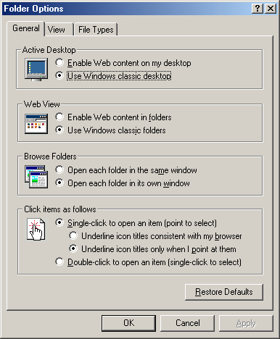

The settings pictured above will give you the fastest drawing of folders (as no web content is shown) & allows folders/programs/shortcuts, etc. to be opened with a single click of the mouse. You can change this to suit your own needs, but this is what I would recommend using.
E.) Autoexec.bat & config.sys – Windows 9x
This is more intended for Windows 9x than Me as Me tends to screw around with the autoexec.bat & config.sys. Good to go ahead and make some tidy adjustments. Open the C:\ drive, select config.sys. Right click it, select Open with. Use Notepad to open it. Add the following line to the file (If you must add anything at all).
Stacks=0,0
You should remove all other lines in this file. This will increase available memory & the other lines are only required in DOS mode, not in Windows. Save and exit.

General Software & Hardware “Tweaks” or Adjustments
Hardware installed can vary as well as software (programs), this section will give a few “tid-bits” and things to look for :
1.) Windows IDE Hard Drive Cache Package :
The Windows IDE Hard Drive Cache Package provides a workaround to a recently identified issue with computers that have the combination of Integrated Drive Electronics (IDE) hard disk drives with large caches and newer/faster processors. Computers with this combination may risk losing data if the hard disk shuts down before it can preserve the data in its cache.
Download the update for Windows Millennium Edition from Windowsupdate
2.) Sound Cards such as Sound Blaster Live can utilize more than one IRQ and PCI utilization – more than what is required. As in the example below, Creative Multimedia Interface and SB Emulation are disabled - this does not impact card performance. The emulation on SB is for DOS legacy operation (not needed).
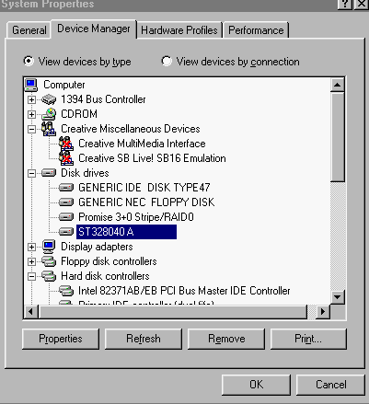

3.) RAID & UMDA-66 / 100 cards have become very popular for striping hard drives together. One designed by Promise (Fasttrak) have a utility that allows interface with PCI utilization. This is very useful in minimizing conflict of HD during heavy load with editing codec cards and may be adjusted differently for capturing versus editing mode, etc. Also models such as the Fasttrak have capability to run disk checking such as SmartCheck. This type of disk checking tool should be disabled as they can drastically impact performance (causing dropped frames, sync errors and disk full errors).
4.) “Take out the Trash “ - Win98 / ME is a packrat. As you work, it collects a prodigious number of temporary files, and it does so for a good reason: The \Windows\Temp, \Windows\Temporary Internet Files, and Recycle Bin files all exist to give you fast access to items you might need again. But there's a point of diminishing returns. And you can end up with hundreds of megabytes of these files, wasting space and decreasing performance as the operating system tries to wade through the rubbish. To keep the trash to a manageable minimum, you should periodically run Disk Cleanup. You'll find this utility on this Start Menu submenu: Start > Programs > Accessories > System Tools.

Defragging is always a good idea, but it's triply beneficial in WinME. You'll find the Disk Defragmenter icon in this Start submenu: Start > Programs > Accessories > System tools. (The program file is DEFRAG.EXE and it's found in the \Windows folder.) Defrag performs three tasks to enhance performance: It places the pieces of all your files into fast-loading contiguous areas of your hard disk, moves your most frequently used files to the front of the disk where they'll load fastest, and groups your applications' separate pieces into the most efficient load-order. Defrag often.

5.) Virus Checkers - All virus scan programs must be disabled before attempting to do video capturing and/or editing. Disk activity is too severe during video editing and can not tolerate virus scan. Insure that the program(s) are set to manual and that they do not re-initiate to automatic with boot-up mode.
6.) BIOS Changes possible for RAM - RAM tweaks
Seeing as RAM is a lot better performing than the Swapfile, it can help a great deal to optimize your memory settings. Restart your PC & enter the BIOS. The following settings, generally contained in the Advanced chipset features/Chip configuration section, can greatly improve memory performance &/or stability.
Bank 0/1, 2/3, 4/5 DRAM timing. Use this to set the DRAM memory module timing. Most BIOS’ default to 10ns. Other options available may be (depending on BIOS) 8ns, Normal, Medium, Fast, Turbo. Selecting a different setting may improve RAM performance, but reduce stability. Turbo is the fastest setting; 10ns is the slowest (& most stable).
DRAM Clock. With the VIA Apollo 133 based motherboards you have the option to change SDRAM speed. Settings available are Host CLK or +/-33. Host CLK allows the SDRAM to run at the same speed as the Ext. Clock (FSB). You can use the +/-33 if you want to run the RAM slower/faster than the Ext. Clock, e.g. If your Ext. Clock is 100Mhz you could use +33 to allow your SDRAM to run at 133Mhz. This is a great option for those of you with PC 133 SDRAM. Or alternatively you could run at a 133Mhz Ext. Clock while your RAM runs at 100Mhz by using the -33 setting. Or you could run PC133 RAM at 133Mhz on a 133Mhz Ext. Clock (aka FSB) by using the Host CLK option. As you can see this option allows for many possibilities.
Delay DRAM read latch. The lower the value for this the better the memory performance, although stability may be affected. Higher values may improve system stability at the cost of performance.
DRAM speculative leadoff. Enable this for better performance, although it could make your system unstable, disable it if it does.
Memory Hole At 15M-16M. Some old add-in cards need this enabled to work properly. If you have such a card then enable this, otherwise disable it.
Memory parity/ECC check/DRAM Data Integrity Mode. In the unlikely event you have ECC (Error Correcting Code) memory installed then you should set this to ECC, otherwise set it to non-ECC. Most memory is non-ECC & not really recommended for most users unless the need the added stability (some claim it is slower when ECC is being used – I use it and do not experience it being lower).
RAS active time. A high number will increase performance of the system's SDRAM. Decrease if stability is affected.
RAS to CAS delay. This should be set to a low number, although it is affected by the quality of you RAM, so set it higher if you have any difficulties afterwards.
Read around write. This is a DRAM optimization feature. If a memory read is addressed to a location whose latest write is being held in a buffer before being written to memory, the read is satisfied through the buffer contents, & the read is not sent to the DRAM. Set this to Enabled for better memory performance.
SDRAM Bank Interleave. For best memory performance set this to 4-bank/way, although lower settings may help improve stability.
SDRAM CAS Latency Time/SDRAM cycle length. This sets the CAS latency timing of the DRAM system memory access cycle when SDRAM system memory is installed. Setting this to 2 will yield better performance, although may be less stable if your SDRAM is not CAS2 rated. 3 is slower & should be used when SDRAM isn't CAS2 rated or you want to improve stability. NOTE - CAS2 can significantly improve performance in many ways.
SDRAM Precharge control. When Enabled, all CPU cycles to SDRAM result in an All Banks Precharge Command on the SDRAM interface. Setting this to Enabled should improve RAM performance. NOTE - When overclocking, particularly when you have an AGP graphics card that’s running at non-spec AGP bus speeds Disabling this may improve stability.

7.) USB, Parallel, Network Cards & Modem ports - Various software programs can be integrated with USB & Parallel Port Hardware as well as Modems & Network Cards. These may inadvertently produce unnecessary polling along the PCI bus. When operating in Video Editing Mode disable your USB, Parallel Port, Network Card and/or Modem. If using a USB port mouse may consider getting standard PS/2 type. If these items are frequently needed you may set up various user bootup profiles to avoid having to go into Device Manager to enable. Leaving these active while editing can impact performance.

- Premiere “pref” file – On Adobe Premiere 6.0 this file is identified as Prem60 and for 5.1 it is Prem50. These can be found in Program Files >Adobe folder > Premiere 6.0 (or 5.1). Icon has a key.
. The file is used by Premiere to hold preference settings and certain instruction code with regards to settings used, etc. Sometimes this can become corrupt and will manifest in the strangest ways (slowdowns, faulty transitions / filters, sync or poor playback, etc.). If you have problems which can not be contributed to any new hardware or software change try deleting this file. When Premiere is started (initialized) it will make a new file. However, BEWARE all of your video, drive selection settings, etc. in Premiere are now defaulted to standard Adobe settings. You will have to go back in and reset drive paths, codec settings, etc. To avoid this I make a copy of the Prem60 file once I get all my preferences set and have proven things are stable. I then save this file in a non Adobe folder. I then replace old / corrupted Prem60 folder with the spare copy – then don’t have to go back and change preferences, etc.
Here are a few ways to tell if a file is corrupted in Premiere (note not all of these are attributed to Premiere “pref” file corruption).

1.) When alt + scrubbing over the file for preview, Premiere bombs.
2) Audio drops out under the clip, but when the clip is removed, audio is fine.
3) A frame is repeated twice somewhere in the file. You can find it by going frame by frame.
4) There is an "error" in the timeline that causes black flashes in transitions, at the end of clips, or a frame from earlier in the timeline flashes at the end of a clip. This error can be duplicated "down the line" and effect files farther down in the timeline. Often it's hard to find the file that's causing the original error. Often times, moving a clip and then moving it back into place can temporarily fix the error. Also, sometimes it doesn't show up when you render the file to disk (as opposed to just viewing from the timeline.)

9.) Faulty RAM - There have been all kinds of stories with regards to impact of faulty RAM modules. I have seen instances where the computer seemed to function properly until editing, then all kinds of instability occurred. Later it was attributed directly to the RAM itself.
I think the following testimonial (from a recent post) sums it up perfectly (brand names deleted as they are not important to this exercise) :
" Here's an update about my problem (that is now solved) that might help you help other customers. When I was successfully using the "......... capture card" I kept adding ram as the prices kept coming down. I ended up with 3 sticks of 128mb PC100, and 1 stick of 256mb PC133 in the 4th slot. All worked fine. When I replaced the ".... card" with the "......capture card", all worked fine for 4 days of lots of capturing, playing and editing then all of a sudden, without me making any changes, the "......" stopped working but everything else on the system worked fine. After more than a week of pulling my hair out, replacing the motherboard, etc., etc., the problem turned out to be caused by that PC133 memory stick in my “………. Motherboard”. Even though the system worked fine with it for a considerable time, it finally started causing problem. I assumed that the memory mix was ok since the system did work ok for a time even with the new capture card. Now I can make the problem go away or come back simply by inserting that memory stick or taking it out. Lesson learned: don't mix memory no matter how sure you are you think it will work “.

- System Cooling
Many incidents have been reported with editing "timeline freezes"; especially after heavy work with the RT-2000 3DFLex chip. Causes have been traced to overheating and malfunction. Of course these type incidents can be avoided with extra cooling fans / systems. Some incidents have been reported to occur when fan blades on the CPU cooler get obstructed or pulled off. Most motherboards have a CPU temperature sensor right beneath the CPU socket and will shut down your system if the temperature gets too high. There are usually extra sensor connections on new motherboard designs to allow extra probes to monitor other areas and software programs that can be used to alarm.

One additional tip : Adding additional air movers is good but some people overlook the actual flow path of the air. There should be fans forcing air in on one side and on the other side oat least one drawing air out. If don't defeat the purpose and actually have poorer circulation. Some slap those suckers in not looking at air direction. Second with additional air passing through more dust is run through and accumulates. Being a chemical engineer (my real job) I can tell you that dust build up will hinder heat transfer “a lot”. Good to give cards a blast of canned air every 2 - 4 weeks (depending on usage).

Final “TWEAK” for SLOW EDITING SYSTEMS

This last “tweak” can improve operating system and application speed by up to 15- 20% by aligning your files for Windows to make them run faster (the computer dynamically. aligns all files loaded into memory anyway, so doing it beforehand saves CPU time). This tweak is not of risk and is not too difficult – it just involves additional programs to do. Windows has a little program that is included with it called walign.exe. The first of these things is that if you don't have Office 95/98/2000 installed the program will not work properly for you. There is, however, a registry trick that will fix this problem for you. Windows Magazine has written a little batch file and registry patch package that works wonders. It even includes an undo option of the optimization fails. Here's how it works:
Can go to : http://www.techweb.com/winmag/win98/winalign.htm
I personally use a program Nut’s & Bolts that gives you many options to defrag, including reordering and positioning of swap file. I use it often on my system drive as well as audio and video drives. It is just as important to keep system drive defrag and files positioned right as A/V - sometimes even more so.
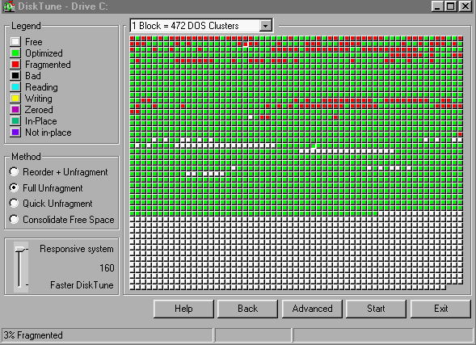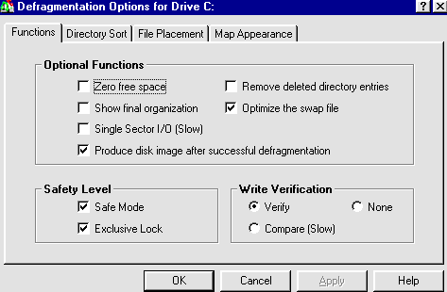

In Conclusion
I think the “tweaking” steps outlined in this document is why some systems seem to run forever, are rock solid, and suffer none or trivial resource leaks; while others are memory sieves that have to be rebooted on a regular and routine basis. Systems that run good apps to start with; and that also have their entire memory system tuned to perfection; and that clean up after mishaps; are the stable ones.
If your system isn't as stable as you'd like, get rid of the bad software, take control of your swapfile and Vcache settings, align your apps, and then clean up after crashes. Chances are you'll achieve a whole new level of stability that you never thought possible!
It may be time consuming to read all that is documented here but will save you hours of frustration later. It’s “pay me know (in preparation and attention to details) or pay me later (with ruined or lost editing)“.
For those that made it through the entire document a couple of little known “tid-bits” ---- for free :
- If Media Player 7.0 doesn't play your digital video files as smoothly as the older Media Player did, you'll be happy to know that "MPLAYER2.EXE" (also known as Media Player 6.4) is still there. You'll find it in the "Windows Media Player" folder (in the C:\Program Files directory). If you want to go back to that version just re-associate your video formats to this player and it will be your new default media player in Win Me. You can do this by right-clicking a movie file, choosing "Open With..." and simply browsing to the MPLAYER2.EXE file. Click the "Always use this program to open these files" checkbox to set it as your new default player.

- Want to use Windows media player to play DVD (not sure why) but here it is :.
1) Run Regedit
2) Navigate to the following folder:
[HKEY_CURRENT_USER\Software\Microsoft\ MediaPlayer\Player\Settings]
3) Create the following "String value": EnableDVDUI
4) Give it a value of: yes
Restart your PC and insert a DVD disk into your DVD drive, open Media player, click on File & Open DVD.
The Summary “TWEAKS” Table Follows :

David LaBorde 4/2001

TWEAKWinVE Summary Table (CheckList) ver 1.0

Windows ME Version

Item # | TWEAK Utilized | Current Setting | New Setting
1 | Virtual Memory – Specify own see page # 2, 3 & 4. Set to specify own and for 256 MB or less = 2.5 X RAM or > 256 MB then = 2 X RAM  MIN & MAX settings
2 | Hard Drive Service page # 4 – Disable write behind caching for all drives & disable system restore.
3 | Vcache – Pages # 5 & 6 – Setup MinFileCach= ¼ RAM X 1024 for RAM > 128 MB or 1/8 RAM X 1024 for RAM 128 MB or less. Set MaxFIle Cache== ¼ RAM X 1024 for RAM. Set Chunksize per page 5 & 6.
4 | [386Enh] Settings Page # 6. Add line ConservativedSwapFIle=1. Add DMABufferSize=64. Add PageBuffers=32. Potential to add LocalLoadHigh if < 128 MB RAM
5 | Set Computer Role – Page #7 . Set to Network Server. Set Read-ahead Optimization to none. If RAM > 128 MB can try 50 % and full.
6 | System Configuration Utility pages # 7 – 9. In General tab “un-tick” Load Environmental. Start-up tab turn off all TSR except Scan reg, System Tray, MxvfxStartup & Load Power Profile.
7 | DMA mode for Hard Drives pages # 9 & 10. Enable DMA support. If need be change registry to insure in DMA mode.
8 | Optimizing File System performance pages 10 & 11. Change in Performance tab to select Disable Synchronous Buffer (special reasons to do this). Registry change of contig file size.
9 | Small adjustments pages 11 – 12. Turnoff desktop sound. Adjust display applet. Customize folder options. Disable display clock. Customize folder view options. Adjustment to config.sys.
10 | General Hardware & Software Adjustments pages # 13 & 14. Determine if need IDE Hard Cache Package. Disable Sound Card emulations or extra multimedia Interface. Adjust RAID PCI utilization and disable Disk Checks. Clean up disk and recycle bin. Defrag HD’s. Turn off virus scans.
11 | Bios changes for RAM see pages 14 & 15
12 | Pages # 15 – 16. Disable USB, Parallel, Modem and Network card. If need be delete Prem60(Prem50) file. Discern if Faulty RAM. Check system cooling.
13 | Pages 17 & 18 . Special defrag of system drive to reposition files and position swapfile.

