May 2001
TWEAKWinVE (TWKWVE)
Version 1.0

Preface
I strongly suggest first time readers review this (first) page before proceeding.
TWEAKWinVE (Tweak Windows for Video Editing) was developed for two Microsoft Windows Operating Systems (Windows Me ® and Windows 2000 ®). The document is a separate file for each operating system. I have tried to structure this in two formats: 1.) Discussion Detailed Section - Each tweak is discussed in detail. How and/or why the tweak works followed by step-by-step “how-to-do”. Many include screen captures for reference. 2.) Quick Reference Table - Developed for fast review and rundown (ME only). Those with OS experience can quickly “rundown” the list and make the appropriate checks & changes. The table is setup with a column for entry of current values should the reader want to keep track of changes made, etc.

The concept is that a number of small changes can add up to a significant impact on PC performance. Many of the “tweaks” singularly do not represent a noticeable difference but added together they do make a significant difference. There are, however, a few listed that will make a large impact by itself. After the “tweaks” were made; the “Available System Resources” for Win Me was 99 % (just after boot-up) - Win 2000 had 18 processes running & 97 % available memory Both operating systems were put “through their paces” with typical editing / capturing functions - rendering and “RealTime” transitions/filters. Both were VERY STABLE. Interestingly, the WinME seem to function just as well as the Win 2000 i.e. very little difference in response time when changing RT screens, etc. Testing time was limited; so long editing segments were not done for all test. The NT coded system would be expected to (possibly) produce more stability. That was not necessarily experienced or given the opportunity to do so.

Each Tweak was tested to determine the impact with regards to video editing not other types of PC usage (gaming, etc.). All test were done using the Matrox RT-2000 editing system with Premiere 6.0. This system can produce high processing loads on the operating system and it makes an excellent selection to troubleshoot (replicate high-end use). The computer system used for testing could be considered medium to high-end for 2 Qtr 2001. It utilizes a PIII – 800 Processor and has 512 megs of SDRAM 133. System drive was purposely set on IDE ATA-33 (UMDA mode) – slower swapfile (pagefile) response, etc. The Audio HD was a separate UMDA-66. Video drives were on an ATA-66 RAID device. The OS hard drives were utilized in a portable caddy so that each could be swapped and the same video scenes tested – edited, etc.

The Internet is riddled with information of “tweaks” and or fixes. Many of these are unproven, dangerous and/or not applicable to editing processing power. I have gleaned through many of these and include those worthy. This document would become too large and impractical to list all failures or “snake-oil settings or “tweak utilities”.

"The difference between theory and real life is that - in theory, there is no difference between theory and real life, but in real life, there is a difference." Although all settings have been tested; this author cannot be responsible for entry errors by the individual and/or the “state” that a problematic system may already be in (void of permanent recovery). It would be wise to make a recovery disk or back-up for system restore. No money is solicited just pass on this information to help others experience the exciting field of videography. For new findings and/or problems found in current settings (for future updates) send to : dlaborde@shabakah.net.sa
“Tweaking” steps are why some systems seem to run forever, are rock solid, and suffer none or trivial resource leaks; while others are memory sieves that have to be rebooted on a regular and routine basis. You can take time to read this and make the adjustments or possibly- later make time to troubleshoot system freezes, crashes and loose critical editing time.

Windows 2000 “TWEAKS” May 2001
Not to be modified w/o approval of D. M. LaBorde

Version 1.0
The Windows 2000 Operating System (OS) platform is based on Windows NT. This platform offers (among other things) greater file flexibility, stability (fewer crashes), security and use of memory over previous versions - Windows 98 & ME. This guide was not developed to explore or educate readers on all the fundamentals of the Windows 2000 operating platform but rather explore optimization (tweaks) to make it more functional for Video Editing (VE). Although Win 2000 (Win2K) is better suited for high-end processing (such as video editing) there are a number of issues that can manifest making one believe it is not stable for such use. There are many complaints about Premiere “slowdowns” after lengthy edit sessions, etc. I hope to at least address and in some cases remedy the problems that might surface on specific hardware systems. Given the number of problems that have surfaced in Video Editing forums (related to Win2K); I have devoted a whole section of frequently posted problems and potential “workarounds and/or fixes (solutions) relating to hard drive transfer rates. Most of this actually pertains to hardware issues, drivers and interaction with Windows 2000 OS.
Many of the “tweaks” given will initiate a message that a shutdown is required for the change to take place. It is suggested that the viewer not cancel shutdown for more than 2 or 3 changes before initiating a reboot. All the tweaks have been tested but any given condition (registry settings and equipment drivers) can vary enough (on an individual’s machine) that a conflict is possible though not likely. Should one occur, a small number of changes; can make troubleshooting much easier. If equipment / registry conflicts occur; a reboot into safe mode (F8) should allow one to return to previous conditions, etc.
System Performance and Preparation (“Success is in the details”)
The more RAM you have - the better. With today's memory prices you might want to optimize your current memory system. Video users should have at least 256 MB RAM to get decent performance using Windows 2000. My test have shown that Premiere 6.0 responds much better with at least 384MB of RAM but 256MB (with proper tweaks) is achievable and effective in “RealTime” editing. I will explain this further in this document. The latest DirectX 8.0a and 8.0bda patch were used and very responsive / stable.
Before doing any significant number of “tweaks” it is advisable (and actually beneficial to performance success) to do a number of preparatory items. This places the OS in a more responsive- receptive mode for “tweaking”.
- Do a disk scan and repair to clear up bad sectors.
- Do a (system) disk defrag to compact and un-fragment data.
- Scan registry for fragments and compact (compress). To do this safely and effectively programs such as SystemSuite or Easy Cleaner or Norton Utilities. They are much better than tools in Windows. Compressing removes any unused space, making the registry file smaller & faster.
Some of the “tweaks” outlined here involve editing the registry. This may scare individuals that are not familiar with doing this. It is not difficult and the only real concern is to verify (double check) entries before exiting. On the next page I list the procedure for backup. Do not be afraid; I really doubt that you will need this but it doesn’t hurt to be safe. In the appendix there is a section on how to use the disk should your system fail.
Last but not least. Win2000 affords much more flexibility and with this comes more complexity. There are specific tweaks that vary with hardware, editing methods and/or software used. I cannot give exact settings for each scenario but hopefully I give you the information and “how-to” test, monitor and make the right judgement to set the proper value or setting. Many of these “hints” give you a method to test and quantify results. Trust me; you are going to need this stuff and might as well take time to read thoroughly. I suggest this not because I wrote it but because Win 2K is that complex when integrated with a video editing system. There are a lot of options and they do work - you just have to decide what is right for you.
Backup
Customizing the various system Services settings and registry can be hazardous at times. So before you even start messing with them you should prepare an ERD (Emergency Repair Disk). Although it’s highly unlikely you’ll need this, it never hurts to be prepared. You can use the Windows 2000 Emergency Repair feature to fix problems that may be preventing you from starting your computer. This includes problems with your registry, system files, partition boot sector, and startup environment. You may not be able to use the emergency repair process to fix your system unless you have created an Emergency Repair Disk (ERD). To make an ERD :
- Click on Start, Programs, Accessories, System Tools then Backup.
- Select the Emergency Repair Disk option in the Welcome tab & also “tick” backup your registry (This is where any changes you make to the system Services are stored).
“The TWEAKS”
The easy one first – It is easy but is going to take a few minutes to explain and go down the list. However, it will be fruitful (every little-bit counts).
1.) Administrative Services - Like previous versions of Windows NT, Windows 2000 also uses System Services. These allow support for other Programs/Hardware, etc. to run correctly. You can configure them to improve system security, etc. By default Windows 2000 automatically runs many of these services & consumes more memory than it actually may need for your particular needs (e.g. If you don't intend to use Task Scheduler or Fax Service, then why waste memory running them automatically) The list contained is rather long and I only give a brief synopsis of what each is. By doing this you will reduce the amount of memory consumed by the Services program (services.exe). I note specific differences should you require network connection (if not will instruct you to set these to manual).
In my case with default installation settings System Services showed 28 items and they were using about 4.5 MB of memory. After customizing the Services (mostly setting to manual) memory consumption for services.exe was reduced to 18 items down to 3.0 MB of memory (25 %).
Before doing anything you should make sure you have the latest system components, & any other relevant updates installed. This will ensure all Services are displayed & in some cases may even fix issues with some of them. To make a quick check of your where your are : hit “cntrl-alt-delete” and select the “Task Manager” tab. Look down at the bottom at the number of processes and also services.exe (amount of memory) and also Mem Usage at the bottom. Make a note of these. (also note processes are higher in the picture below i.e. not 18 as the capture services were open to copy this)
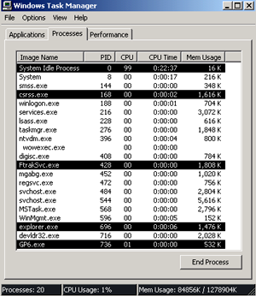
Begin by logging on as Administrator. This will give you access to all the Services available in Windows 2000. To load the Services Utility, click on Start, Settings, Control Panel, Administrative Tools, then Services (You may also be able to access it via Start, Programs, Administrative Tools, Services if you enabled Administrative Tools to be displayed on the Start Menu). Below is a display of the Services utility.
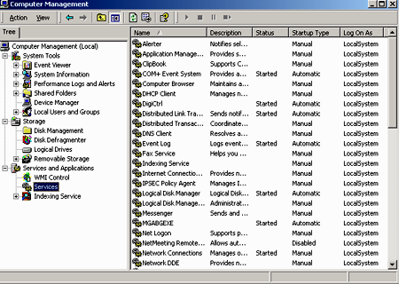
This Utility lists all the Services that are available on your system. In particular look at the Startup Type tab, this attribute is the most important one & is the one we will modify. Three options are available & they are listed in the following section.
Disabled, Automatic or Manual? There are 3 choices for each particular service available.
- Disabled. - This makes sure the Service is not started while loading Windows 2000. If it is needed it cannot be started either until you set the Startup Type to Automatic/Manual & Reboot, or Start the service. This will help decrease boot time.
- Automatic. The Service is automatically initiated while loading Windows 2000. This can increase boot time. Certain Services must be set to Automatic in order for Windows 2000 to function correctly.
3. Manual. The Service is not started while loading Windows 2000, if needed; it can be initiated. This will help decrease boot time but system performance may degrade slightly while the Service is initiating – Note this is no big deal.
In order to change the Startup Service - enter the Properties of the respective Service. Right click on the Service in question & select Properties.
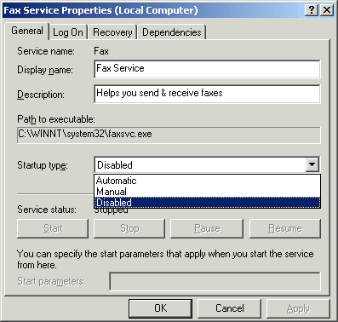
From the Startup type drop-down menu you can choose the Services Startup type. Select Apply after you have made your selection for the change to take effect. Select Ok to return to the Services Utility. NOTE – In most cases I recommend that you set a Service to Manual rather than Disabled (As discussed earlier the only difference is that a Service may be started if needed, rather than not at all). That said, as you'll discover later on in this guide there are certain instances were it can be preferable to select Disable rather than Manual.
Dependencies (“one last thing to know - then we change stuff”)
A Dependency is a relationship of reliance between 2 or more resources that makes it necessary for them to run in the same group on the same node. In relation to Services, some are dependant on others to run correctly. To find out whether or not a Service is dependant on others, Right click on the Service in question & select Properties. Next select the Dependencies tab.
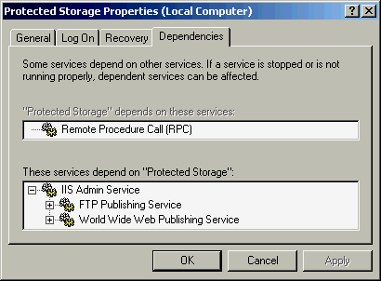
Depending on what dependencies a Service has, it can effect your ability to change a Services Startup type to Disable or Manual without the Service being automatically initiated anyway. As a result this tab can help your Troubleshooting process if a problem arises after disabling a particular Service that is dependant on it.
To make this document easier to use and resource I have included the list of services and settings to change in Appendix VI (page 37). I would suggest you go down the list (one-by-one) to make the setting changes. Afterward go back to the Task Manager. Should there be a problem with start-up after making the changes refer to Appendix II on what to do. Note – nothing should happen but operator entry error, etc. can occur and I list method to correct in the Appendix II (Emergency restoration of Services or Registry).
2.) Testing, monitoring & troubleshooting – To adequately assess your system and troubleshoot you need to understand tools and methods available to do this. In fact you can learn how to determine how much resource an editing program (such as Premiere) needs / utilizes and what load fluctuations occur. Windows 2000 has an excellent monitoring tool within the Task Manager and Administrative Tools. Everybody’s system and editing needs are different; so you’re going to have to learn how to use these tools. I could build an editing system, boot it up, let you edit with it and send it home with you. Later you would wonder “what the heck happen ?”, everything seems to have gone south!!! The poor editing/capture makers, programmers, “turnkey” suppliers and installers get falsely blamed. Well at least sometimes it is not their fault. There are answers why this can and will happen.
You will learn how to monitor and adjust things according to your editing style / needs, equipment and software. This is not difficult and once you learn the basics, very time saving. The two basic monitoring systems will be the Performance section of the Task Manager and Performance log initiated in the Administrative Tools Section. In Appendix III I give the details on how to setup the Performance log. I advise you do this so that it can be utilize later in editing sessions for optimum “Tweaking”. The actual Performance Monitor is easy to setup. First hit “cntrl-alt-delete”. The task manager screen will appear.
Select the Performance Tab - Here you will see CPU usage, memory usage and number of processes running. We will discuss all of this in detail but we must build a foundation of how to use the properly. Note you can use this while editing but open it before loading the editing program (e.g. Premiere). It utilizes a small amount of resources but not enough to have a significant impact on performance. I wouldn’t routinely do this but in beginning do so to get your system optimized (“tweaked”).
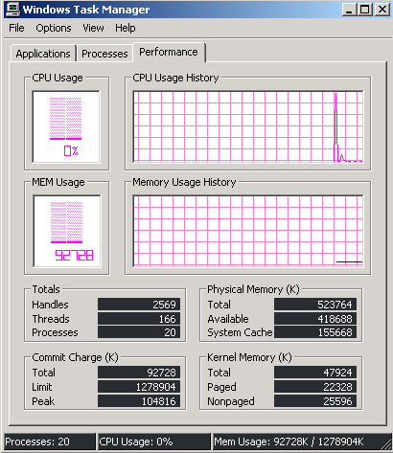
To wet your appetite look at the display below. It was taken after booting Premiere 6.0. Notice the differences from it and the one above taken just after Windows boot-up. Notice the difference before and after (327.8 Meg minus 92.7 meg = 235.1 added). We will discuss this in a moment under memory usage. Note 1024 bytes = 1 Mega byte & Physical RAM = 512 MB.
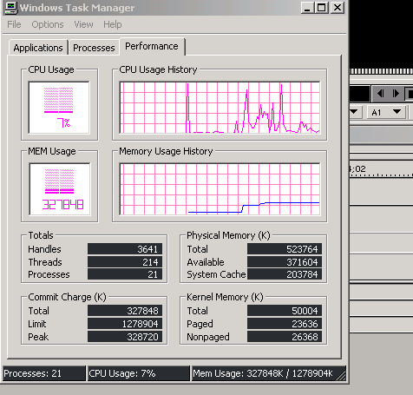

4.) A “Quirk” of Windows 2000 - I mention this early as it can cause significant problems. Windows 2000 comes with an abundant of drivers for all kinds of devices (hardware). These are included to make install of Win 2K possible without removing PCI cards, etc. The drivers are generic in nature even though many will actually have the device’s manufacturers name (e.g. Promise Fasttrak or HighPoint, etc.). The problem is that many of these do not work and have been modified. The “quirk” in Windows 2000 is that - often an individual can think that they are installing the latest driver and yet Win 2K actually installs the generic driver contained in the system drive (C:\WINNT) folder. The key when loading drivers is to watch the install window to see where Windows is accessing the drivers (during the actual load sequence). The Display on the next page highlights this. If you see Win2K revert to the driver in the system folder you may have to check the box “Install one of the other drivers”. This sometimes doesn’t work and the only option is to find the generic driver (ID during the load) and relocate or delete it.
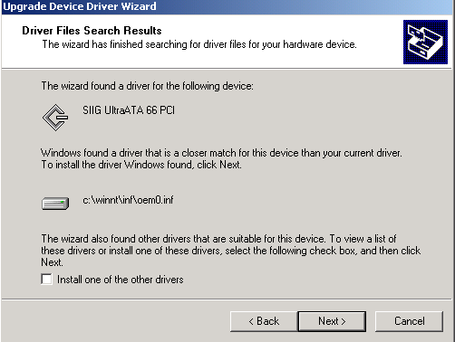
Notice generic

It is advisable that you go and check each hardware component driver to insure you have the latest version (even though – you think you loaded the right one). To do this – right click My Computer > Properties > Hardware > Device Manager > Double click on each device – select the Driver Tab and look at the version & date.
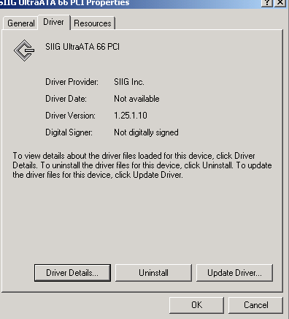

We will now work though various system principles such as hard drives, memory, etc. We work in sequential steps to better understand how to “tweak” & troubleshoot.
5.) Hard Drives- “This is oh so very important to video editing”. The various video editing forums are riddled with problems ranging from dropped frames to poor transition / filter operation to “lock-ups”. Many of these are the result of poor hard drive performance. The hard drives themselves are typically more than adequate and many performed admirably when used on Windows 98 or ME. Many users are confounded why drive performance deteriorates when they upgrade to Win 2000. Some of these problems are the result of drivers, Win 2000 itself and/or poor setup. Last but not least; problems can be hardware, the drive themselves to the cables, etc. For those “unaware” I proceed with a little background (for expert videographers this is not long and it never hurts to review things). There is a big default problem that Win2K has that impacts UDMA mode. We will discuss this-“so keep look-out".
DMA (Direct Memory Access) allows your Hard Drives or CDROMs to access memory directly, thereby freeing up CPU resources. You can enable DMA on a per channel basis, and all devices on that channel have to be DMA capable, but most drives these days are (although some CDROMs may not be).
To enable DMA, right-click My Computer, choose Properties, Device Manager, click on Device such as "IDE ATA/ATAPI controllers." Double-click on the controller you want to enable, and in the properties window that appears, click the Advanced Settings tab. Each device has a "Transfer Mode" that you can change to "DMA if available." Choose that setting to enable DMA.
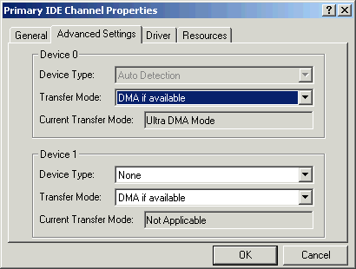
For Transfer Mode you should select DMA if available. PIO Only is much slower than DMA transfer rates & the Page File (discussed later) benefits from a faster data transfer rate, assuming the hard drive(s) support it. Click Ok & reboot your system for the changes to take effect. NOTE – If you have no other IDE devices on an IDE channel, then selecting None will reduce boot time.
There are actually 3 Ultra DMA modes available : Ultra DMA 100 has a maximum bus transfer of 100 MB/sec, Ultra DMA 66 has a maximum bus transfer of 66MB/sec which is twice the bandwidth of Ultra DMA 33 (33 MB/sec). Test have shown that sustained rates between the three are not necessarily that much different on many MOBO. Much of this depends on Bus speed, processor and the like. What is different between each is the burst rate and bandwidth. The higher you go; the higher burst rate and increased bandwidth. To adequately get these kind of transfer rates, special 80 pin cables are used versus the standard 40 pin.

Watch “tweaks are coming”

A.) Windows default for DMA - There are 2 very important items regarding this. First -Win2K requires a “fix” to operate in DMA-5 mode (100 ATA drives). You can obtain this on the Microsoft sight at http://www.microsoft.com/downloads/release.asp?ReleaseID=22161. Second – This is very important - Windows 2000 defaults UDMA mode to UDMA-33 not 66. Regardless to what you have in your Bios and what you have selected in device manager; the mode will not be greater than 33. This will impact any on-board IDE connected drives. This includes any second-party drivers like HighPoint, etc. Separate PCI UDMA & RAID cards are not affected as they have a Bios and control method separate from the MOBO Bios. To select to UDMA-66 mode you have to go into the registry and edit it. To repeat - you must go to My Computer icon -> click Properties -> Hardware tab -> Device Manager -> IDE ATA/ATAPI controllers item -> select Primary and/or Secondary IDE Channel Properties -> click Advanced Settings tab -> look under Transfer Mode for the "DMA if available" setting (you must also have "Ultra DMA Mode" active in the window that says Current Transfer Mode for this to work).

Registry change - Again this is not difficult or harmful, just pay attention to your entry. To make the registry edit do the following : (You must be logged on as Administrator to be able to do this)
To activate the ATA/66 (UDMA/66) setting, you need to go to Start > Run – Type Regedit : Goto :
HKEY_LOCAL_MACHINE\System\CurrentControlSet\Control\Class\{4D36E96A-E325-11CE-BFC1-08002BE10318}\0000
Note that the "0000" key above might show as "0001", "0002" or "0003" on your machine, depending on your particular hardware settings. Select the key appropriate for your Bus Master IDE controller.
Click on Edit > New and create a new DWORD Value, call it "EnableUDMA66" (no quotes), click in outside area to see if it is labeled right then right-click on it, go to modify and type 1 in the Decimal box to (select Decimal not hexadecimal) enable ATA/66 (UDMA/66) support. To disable it, change the Decimal value to 0, or delete the "EnableUDMA66" Value altogether.
Reboot when done.
B.) Disable Paging Executive - By default, Windows 2000 will allow portions of the operating system code and some drivers from physical RAM to the paging file. If these drivers or code are needed after they are paged out, the system slows or stops while they are read back into memory from the paging file (this is by design ). If you have ample amounts of RAM (> 384 MB) you can use the following Registry setting to keep these items up in memory:
Hive: HKEY_LOCAL_MACHINE
Key: System\CurrentControlSet\Control\Session Manager\Memory Management
Name: DisablePagingExecutive
Right click & Modify - Value: 1
A value of 1 disables paging of system code and drivers, a value of 0 (default) allows them to be paged to disk. I would try this one if you find you are having problems with long edit sessions (slowdowns and system monitor shows high paging file usage). If not having problems I wouldn’t do.
Specific Hard Drive Transfer Problems – Many Win 2000 Up-graders have experienced all kind of transfer degradation. In Appendix IV I have listed a number of forum post from the Web. There are many “work-arounds” and actually some variations in fixing the same problem. Those with problems should not pass this up.
Personal Example - I had an experience with a Windows 2000 upgrade involving HighPoint UDMA-66 on-board controller. Under Win 98/ME the controller worked flawlessly. I had DVD and CD-ROM R/W drives on IDE #2 port (ATA-33), nothing on IDE #1 and IDE#3 contained the UDMA system drive. In the MOBO Bios; the IDE#3 was set for UDMA-66 and for initial boot. My Audio drive was set on IDE # 4 and for UDMA-66. After loading Win 2K and HPPT Win 2K drivers the system would not boot. After changing Bios on HPPT to ATA-33 mode the system would at least boot and drive test revealed that the drives on both IDE #3 & #4 were actually running at PIO speeds (10MB/sec). When I tested the editing system it was sluggish. It would do Real Time 3-D flex transitions from the Matrox RT-2000 but when I tried Organic wipes the system would hang (will become obvious later why). The video drives were on a RAID (PCI) controller and after loading Win2K drivers they tested just fine ( 29 - 31 MB/sec).
I loaded the UMDA-66 fix in the registry and then switched the system drive to the IDE #1 port (ATA-33). The system booted fine and the System drive then tested reasonable for ATA-33 mode. The Audio drive (on the other HPPT UDMA-66) then tested very close to the RAID. The system drive is adequate for editing using UDMA-33 especially when paging file is placed on the outer area of the disk (will explain later). There are fixes to get the system drive back to the HPT port and that can also be found with others in Appendix IV.
With regards to File format and Fragmentation we will discuss these after exploring paging files and memory as these also have an impact.
Hard Drive Testing - With recent problems associated with Win2K and hard drive transfer rates, I believe it is important to discuss (briefly) ways to test and troubleshoot drive transfers. There are numerous articles about transfer rate, differences in read-write mega-bits and mega-bytes. We will not discuss that here. There are three tools I have used to measure and troubleshoot. If you are using the Matrox system it comes with a disk benchmark test program. It is very efficient and can analyze – simulate disk operation up to “x”% full. The problem is that it takes time to do this and if data is already on the disk it is not as accurate. There have also been some reported problems of inaccurate results when using Win 2K. I have, however used it intermittently to test drives. I simply initiated the test and looked at the instantaneous results for a few seconds rather than wait for the full test. You can get a good understanding of performance with regards to major transfer problems (UDMA mode versus PIO,etc.)
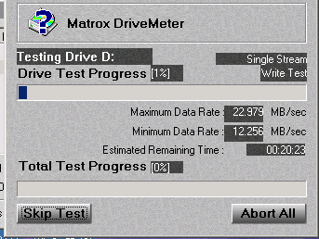
Inst. Rate
Audio UDMA-66
There is also another little nifty little program that I frequently use. It is free and can be found on the Canopus Web site. The test is called RexTest. You can run it on any drive and only takes about 15 sec. to do the Read / Write test. I use this for quick troubleshooting and run it often to just test how drives are behaving before starting an editing session. Beware - this test gives a general snapshot look at disk performance. If disk is fragmented you may get a fluctuation in results and you may have to run 2 or 3 times to understand better. In a way this is good as it indicates a defrag is probably in order.
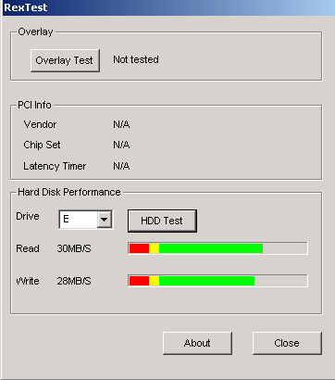
RAID – ATA66 Video Drive
The third program you might consider HDTach. This program is $49 and is used in detailed test. It is very good if you routinely do troubleshooting.

Hard drive setup – “One last setting to check”
Open My Computer, right click on the hard drive(s), select Properties. Select the Hardware tab. Now highlight the desired hard drive & click the Properties button. Finally, select the Disk Properties tab & SCSI Properties, where applicable. The following options can improve Hard drive performance. NOTE - Some of those options may, or may not be available depending on hard drive type, e.g. SCSI or IDE.
Write cache enabled: If you enable this feature, your computer sends an enable-write-cache command to the hard disk activating the hard disk write-back cache, & if you disable this feature, the hard disk write-back cache is deactivated. When enabled disk I/O performance may improve, although if you experience system failure e.g. Power loss, you could experience drive/file corruption. I would recommend leaving this ticked unless your system is prone to bad shutdowns/power failure.
Disable Tagged Queuing: Tagged queuing is done by the SCSI controller & driver to increase the speed of completing I/O tasks. This is accomplished by sorting the commands so the order of the commands issued to the physical disk drive to read or write results in the most efficient movement of the physical read & write heads. Doing it in this sequential order is far more efficient than when disabled, resulting in greater I/O performance. You should only tick this if you are experiencing problems with a hard drive(s) as performance is slower when Tagged queuing is Disabled. Leave it unticked.
Disable Synchronous Transfers: There are 2 methods of transferring data over SCSI cables, Synchronous & Asynchronous mode. Asynchronous mode transfers use an interlocked handshake method where a device (adapter or drive) cannot do the next data transfer operation until it receives positive acknowledgment that the other device received the last data transfer properly. Synchronous transfer mode permits the sending device to send multiple data packets without receiving acknowledgment that the receiver actually received every data packet sent. As a result, more data can be sent/received before acknowledgement is required. You should only tick this if you are experiencing problems with a hard drive(s), e.g. overlapped requests, as performance is slower when Synchronous Transfers is Disabled. Leave it unticked.
One additional “tweak” - By default, Win2k is set to collect physical drive data.
Most don't need this. To disable the disk performance counters: Go to->Start->Programs->Command Prompt Now type in: diskperf -n then reboot
6.) Memory, CPU & Paging Files – The heart of the computer is the CPU (central processing unit) and the memory banks. Memory stores the instruction and files; the CPU processes the instructions. What is Virtual memory? It is a hidden file on the hard disk that Windows 2000 uses to hold parts of programs & data files (that do not fit in physical memory). The paging file & physical memory (RAM), comprise virtual memory. Windows 2000 moves data from the paging file to memory as needed & moves data from memory to the paging file to make room for new data. The Paging file is also called a swap file.
Another explanation is that it is temporary storage used by the computer to run programs that need more memory than it has. For example, a program could have access to 4 gigabytes of virtual memory on a computer's hard drive, even if the computer has only 128 megabytes of RAM. The program or data that does not currently fit in the computer's memory is saved into paging files. The Operation System (Win 2K) tries to keep everything in RAM, but when everything doesn't fit, it swaps the (least) recently used memory pages to the hard disk, storing them in the paging file. When the user program requires the swapped pages- Windows loads the swapped pages back into RAM and swaps other pages to make room for the pages the user needs. Therefore, where you put the paging file is important and affects performance. It goes without saying that with more memory there will be less file swapping since more can be held in RAM.
The swap file sits on a local drive in your machine and is used to extend the amount of memory that Win2K can access. Since hard disk space is far cheaper but also far slower than physical RAM, you can get a lot of mileage out of a good-sized swap file – however, at the expense of speed. Many people seem to think that all you need to do is buy a 100GB hard drive, and then they have got 100GB of memory! This is not true, partially for reasons of speed. It also takes a certain amount of physical memory to manage each block of swap space. After a while, you run into diminishing returns if you try to stake out a mammoth swap file (mammoth in proportion to your physical memory, that is) and use it as a substitute for RAM by running memory-hungry programs like Premiere.
Setting the swap file size isn't hard. Right-click on the My Computer icon, select Properties, click the Advanced tab, and press the Performance Options button. The existing virtual memory size will be listed there; to change it, click Change. You'll be able to specify page file sizes for each volume in your system. The initial size should typically be set to the "Recommended" number listed under "Total paging file size for all drives". Windows calculates the recommended at just about 1.5 X physical RAM. Maximum size can be about anything your drive can hold. Where it goes is what’s very important.
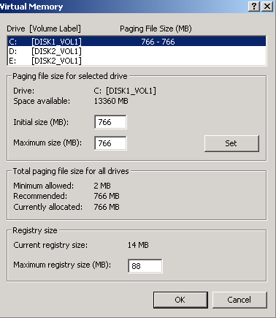
The most basic and obvious trick with the swap file is don't put it on the same hard drive as your operating system. The idea is that the operating system is seeking or writing instruction while also moving data to or from the paging files. The most efficient thing you can do with a swap file is to put it on a drive other than the drive holding Win2K itself. This will speed things up noticeably, because two totally different physical drives will handle calls to the OS and calls to the swap file. This is not a must on some systems and it will become obvious later.
You can place multiple swap files across multiple partitions or hard drives, creating in effect one giant page file partitioned across several volumes. This is a good idea if you've got space to burn on multiple partitions, but bear in mind that the swap file cannot be moved by the Microsoft-supplied defrag tool in Win2K. Placing the Page file on a separate partition of the system drive increases access time & head movement so you defeat your purpose. NOTE – This is not the same as placing it on a separate hard drive(s). If you have multiple hard drives try either placing the Page file Partitioning to a hard drive that your system file is on. An option would be to place it on you Audio drive (if it is separate from video) – it receives less activity than Video and should handle it fine. It is very important to optimize the paging (swap) file if physical RAM is low. Even with large amounts of RAM; heavy editing sessions can also load up the paging file on a system that originally looked very “unloaded”. Now lets look at specifics on this to help you determine what (if any) and how much to “tweak”.
One of the best “tweaks” you can do is place the Page File on the outer edge of a hard disk. There it can be accessed quickest. Windows 2000 Disk Defragmenter won’t do this. You’ll need a disk defragmenter like Norton Speed Disk, McAfee Nut’s & Bolts or others. If you do heavy editing sessions you will eventually have data moved to the swap (paging) file. Remember that Win2K moves stuff to the disk on protocol of least used. Something not used frequently but requested later can then “bog” your system down if it is later polled for and the data is fragmented and/or on the inner sections of a disk. If it is on the same HD as the system disk, even more access time might be needed. Fragmentation, slow disk access and/or high system activity is what often produces sluggish editing. Later people often try different methods, drivers and/or re-installing Windows. Of course boot-downs and reloads shift things and often change the paging files, yet later problem surfaces due to the same phenomenon.
I happen to use Nut’s & Bolts to put page file on the outer tracks – any will do. I even have my page file on my system drive. Access is fine and delays do not occur. Of course I also have 512 MB of RAM but that still fills up with heavy usage. Remember these tips : 1.) Set the size, location and number of paging files to a constant optimal size ( Max = Initial). If you let Windows manage your "swap file" setting, it will change in size as it is used. This will cause it to fragment. If you make a permanent "Swap file", it will NOT fragment as it is used. This will make it faster to use. 2.) The paging file is used regardless on how much physical RAM is in the system. This makes this setting extremely important. 3.) The table below gives optimum locations :
Location | Description
Optimal | Put a paging file on a hard disk (or multiple hard disks) that do not contain the operating system or Put paging file on a dedicated non RAID FAT partition.
Good | Put one paging file on a stripe set with no parity.
Adequate | Put one paging file on a stripe set with parity.
Worst | Put the paging file on the same drive as the system files & formatted NTFS.

You should also check in the Performance options. You have a choice to optimize for either Applications or background services. You want to select Applications, this specifies that more processor resources are given to the foreground program than the background program

I have included a set of registry tweaks in Appendix V. These can be utilized to maximize paging, etc. These can be safely done and may be useful for those with heavy sessions, etc.

If you split your paging files to more than one HD it can increase paging significantly as multiple read/writes can occur (would not be possible with single drive). Set initial size the same to insure equal distribution and multiple sessions.
Enabling the write cache on a drive will also increase its write performance considerably. SCSI hard disks are usually used in high-end systems and servers where data protection is more important then performance. This is why the write cache is disabled by default. This can be enabled in Windows 2000.

1. Right click my computer.
2. Click manage.
3. Click Device Manager.
4. Double Click Disk Drives.
5. Right click the appropriate drive.
6. Click properties.
7. Click the disk properties tab.
8. Click write cache enabled.
9. Click OK.
10. Reboot the PC if necessary

7.) File Format – I am sure you noticed I mentioned NTFS in the table above. So let’s talk about file format : The NTFS file system is different from FAT in that it suffers from gradual fragmentation. This effect can however be offset with regular defragmentating.
FAT stands for File Allocation Table, and it dates way back to DOS days. Beginning with Windows 95 SR-2, FAT was upgraded from 16 bit to 32 bit, so when we refer to FAT, we are actually talking (these days) about FAT32, not FAT16. FAT32 overcame some of the inherent limitations of FAT16 disk and volume sizes, as well as directory entry restrictions, long filename restrictions, and large cluster sizes, which wasted large amounts of disk space when storing small files. FAT32 volumes, in theory, can range in size from less than 1 MB up to 2 TB (TetraBytes). However, when used with Windows 2000, the maximum size of a volume is 32 GB (there is a workaround if on RAID). Also, the maximum individual file size is 4 GB. FAT32 is the native file system of Windows 98 and Windows ME.
NTFS or New Technology Filing System, it is the native file system of Windows NT and Windows 2000. NTFS is a "journaling" filing system, which means that it is less likely to become corrupt, and will recognize errors or bad sections of disk and correct itself automatically. NTFS volumes can only be accessed (directly, not through shares) by Windows NT/2000. Because of the larger overhead, NTFS cannot be used on floppy disks, and the minimum recommended size for an NTFS volume is 10 MB. However, the maximum supported volume size is 2 TB, and there is no limit on the file size. NTFS also supports file encryption, file compression, file permissions and auditing, as well as many fault-tolerant disk configurations such as mirroring and RAID 5
It is difficult to measure the performance differences between FAT32 partitions and NTFS partitions, because there are so many factors involved; such as hardware configuration, fragmentation, file placement on the disk, file caching by the operating system, etc. Performance between the two formats is claimed to be similar, and there are actually several other factors that you will use to decide which is the best format for you. PC World tests indicated that NTFS is far slower than FAT32. This is thought to be due to additional file security and logging overhead. The Search and Replace test in Word corroborates this result: Both Windows 2000 and NT 4.0 (which by default also uses NTFS) took a dramatically longer time than Windows 98 SE to complete the task.

The reason NTFS is somewhat slower is that when a NTFS drive is formatted by Windows 2000 (by default) it reserves 12.5% of that drive for the Master File Table(MFT). The MFT contains information about the files on the drive. This includes size, date and permissions. If lots of files are expected to be added to the drive it is recommended to increase the size of the MFT before formatting the drive. When a file is accessed Windows 2000 it must read the MFT for file attributes. The MFT is actually a file usually stored at the beginning of the volume. It is a database which stores file location and attributes. It also stores data about the volume. Any file accessed on a drive must access the MFT. A heavily fragmented MFT can cause extremely bad performance. Even if the file is contiguous if the MFT is fragmented it will take several I/O's to access the file. I think you are starting to get the picture. A program such as “Diskeeper” can be run on volumes to check for MFT Fragmentation and can defrag MFT. This is, however time consuming.
There are many benefits to using NTFS but placing a swap (paging) files with it is not one of them. I suggest if possible your swap file be on a disk portioned and formatted with FAT32. Studies have shown that NTFS seems more prone to become fragmented than FAT32,
You must use the FAT filing system if you have any of the following requirements:
- You dual boot with any Operating System other than Windows 2000 or NT (note: NT version 3.x or 4.x cannot read FAT32 volumes, only FAT16).
- You want to be able to access the volumes using any Operating System other than Windows 2000 or NT. In other words, if you want to be able to use a DOS or Windows 9x/ME boot diskette to boot the machine and access the volumes.
- You are formatting a floppy disk.
- You may decide later that you want to dual boot. You can convert a FAT volume to NTFS, but not vice-versa: it's a one-way conversion.
You must use the NTFS filing system if you have any of the following requirements:
- You want to be able to encrypt files so that only a certain user can access them.
- You want to use fault tolerant disk configurations such as RAID 5 or mirroring.
- You want to assign permissions to files, specifying which users or groups have access to which files and folders.
- You want to store files larger than 4 GB.
- You want to format partitions larger than 32 GB (there are some workarounds for FAT32).
- You want to audit files for access by certain users or groups.
- You do not want the files to be accessed by someone using a boot disk.
- You need a more robust filing system that is less prone to errors or corruption.
8.) Memory (revisited) – Win 2K / NT categorizes memory as either paged or nonpaged. Paged memory holds data that can temporarily be moved from physical memory to the system’s paging file (if space is needed for different data in physical memory). Nonpaged memory stores data that must be present in physical memory at all times. NT allocates a portion of physical memory for nonpaged memory when the system starts up, and this allocation can’t actually grow much. If drivers or NT exhaust this storage, the system may become unstable or operations may start to fail. Remember the Task Manager screen capture in the beginning. There is a window that shows paged and nonpaged.
Just after Win Boot-up After Premiere Started
If you have reason to believe the nonpaged is exhausted (instability) you can increase size by overriding defaults in the registry. This value is the number of bytes of physical memory you want to allocate for nonpaged memory. To monitor your memory, use Performance Monitor to watch the percentage of committed memory that’s used. If more than 80 percent of memory is used consistently, you should increase this value. Likewise, if the system’s nonpaged memory usage is low, reducing the amount allocated for it increases system performance. The registry change is below :
Hive: | HKEY_LOCAL_MACHINE
Key: | System\CurrentControlSet\Control\Session Manager\  Memory Management
Value Name: | NonPagedPoolSize
Data Type: | REG_DWORD
Value: | <number in bytes >

Paged pool is different from virtual memory size — the paged pool is space reserved in the system’s virtual memory map for NT and device drivers to allocate pageable data.
You can monitor the amount of paged pool the system uses with the Performance Monitor. It also shows the maximum allocation possible. If the amount of memory used is consistently more than 80 percent, you should use this setting to override the default setting in the registry. (refer to capture on previous page – notice paged amount was only about 50% of total physical memory). To change the registry default :
Hive: | HKEY_LOCAL_MACHINE
Key: | System\CurrentControlSet\Control\Session Manager\  Memory Management
Value Name: | PagedPoolSize
Data Type: | REG_DWORD
Value: | <number in bytes >

Let’s look at the performance monitor again :
CPU Usage
CPU Usage is in the Performance Monitor: Processor:% Processor Time and System:% Total Processor Time. Note that CPU Usage doesn’t measure Idle threads
MEM Usage
MEM Usage not only reflects the kilobytes of virtual memory used but can also be tracked via the Memory:Committed bytes object:counter in the Performance Monitor.
Totals
This section refers to several types of system objects including handles, threads, and processes. System objects take up space in nonpaged memory that is managed by the operating system, we are concerned about these numbers. Too many active system objects typically results in bottlenecks at the processor or in memory use.
Total handles. Handles essentially refer to system objects such as open files. Technically, it is the object handles present in all active processes.
Total threads. Reflect executing threads or, stated another way, the number of threads running. This measurement is akin to the Process :Thread Count_Total in Performance Monitor.
Total processes. A process, to me, can simply be thought of as an application. This number reflects Idle processes that run basically when the CPU is sleeping.
Physical Memory
This is easy. Total refers to the total RAM installed on the computer running. It is measured in kilobytes. Not surprisingly, “Available” refers to the available RAM in kilobytes. File Cache refers to the total memory that has been allocated to the file cache.
Commit Charge
This generically refers to memory allocated to the operating system and programs. This is includes both physical RAM and virtual memory. Total refers to the memory (both real and virtual) that is currently in use. Limit refers to the upper limits of all memory combined before the paging file size would have to be increased. Peak refers to highest memory in use during the current session.
Kernel Memory
First, it is important to understand that kernel refers to memory in use by the operating system in kernel mode. Basically, Windows NT operating systems run in kernal mode. Total refers to both the paged and nonpaged memory in use. Pages refers to operating system’s page pool. Nonpaged, not surprisingly, refers to the nonpaged memory dedicated to the operating system.
User-mode and kernel-mode drivers and kernel-mode system code is usually written to be either pageable or non-pageable. In cases where drivers or system code is pageable, you can use the following registry entry to keep this pageable code in RAM. This is only advisable on systems with extremely large amounts of RAM (512 MB or greater).
To manually edit the registry. Modify HKEY_LOCAL_MACHINE\System\CurrentControlSet\Control\Session Manager\Memory Management and set the following value DisablePagingExecutive=1
Now what to do with this with regards to Video editing ? Well some we won’t use.
- Total committed bytes should not be more than physical memory.
- Physical RAM needs to be at least 16 MB above Peak Commit charge.
View after started Premiere

Let’s look at monitor with various actions within Premiere

Refer to next page
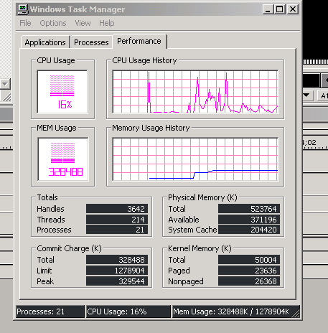
Here is a capture of the monitor after making a few editing changes (e.g. call up file, trim and cut, adjust audio, etc.). Notice that the CPU usage makes excessive spikes. This is normal and as long as you don’t consistently run above 80 % your processor has plenty of power. This machine has 512 MB of physical RAM. If you notice- total physical available (less operating system requirements) is higher than total peak or committed. Therefore no (or at least very little) pagefile swapping had to occur.
Now lets see what if looks like when we called up a Matrox Flex 3D “realtime” transition and previewed it.
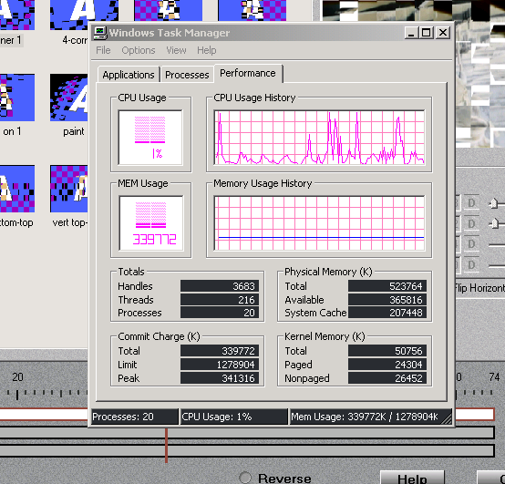
Memory and CPU loading look very good. By the way CPU is PIII 800 with 133 mhz and RAM SDRAM 133. Now let’s look at something intensive like scrubbing the timeline.

Performance Monitor while scrubbing in Premiere
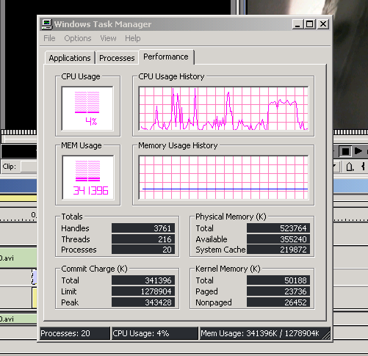
Notice that during initial scrub CPU usage was about 60%. On a 600 mhz PIII this is about 85%. Again memory peak was below available but getting closer.

Performance Monitor while encoding Mpeg –1
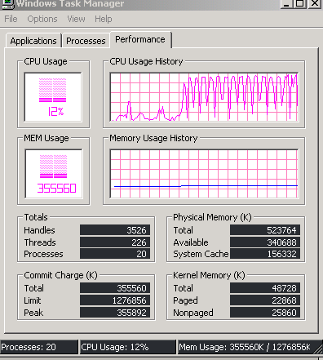
Notice the CPU fluctuation but also notice that Peak Commit Charge was above available, therefore files swapping could be expected to occur. I am not an expert on the OS, system utilization and graph interpretations. However, you can get the picture of what is possible to monitor and analyze.

9.) ACPI - This stands for Advanced Configuration and Power Interface. What does that mean for the computer user? ACPI isn't an OS, an interface or a program. It is what amounts to as a set of guidelines. It is referred to as "specifications". A system was set up by a number of companies (Intel, MS, Toshiba and Phoenix) to come up with more standardized and improved methods of controlling / configuring power in a computer. The initial emphasis was of course laptops, but with WIN 98 it came to the PC as well. The system is MS and Intel's own variant of the new standardization. Intel was looking at a system where it could power down to meet certain EPA and other guidelines, yet be ready to wake up within a few seconds to pick up an incoming phone call or LAN request. This is what is referred to as standby, or suspend to RAM, or the S3 state. MS with “OnNow” was looking more at OS solutions, which may have lead them to their approach in WIN 2000, where everything is controlled by the OS, including hibernation, IRQ’s, etc..
This is where all the difficulties come in trying to trouble shoot ACPI problems. First, there is no real standardization, and secondly, there are so many variables. For ACPI to work, there has to be complete co-operation between all hardware with drivers, all software, the OS and the BIOS. The smallest problem seems to be software, and the hardware and BIOS tie for the largest. To make things worse, every board manufacturer modifies their BIOS - even if it has the same basic version number. The changes can be small, but the consequences are often frustrating. Thus to try and make a troubleshooting page with so many variables (how many BIOS and MB combinations are there ?) would be futile.
There are many users that have experienced very good results. I myself have seen more stability by with “Standard Setup”. There have been posts on various forums referring to test showing slowdowns in CPU speed and/or lower HD transfer rates using ACPI. You will have to test and decide for yourself. If you decide to revert to Standard, there is a method to disable it without reloading Win 2K. MS has posted objection to doing this. They site potential for instability. To do it right requires re-installation and pressing F5 during the initial part of the install.
10.) WFP – Windows File Protection : WFP is used to protect the core system files of Windows 2000 from being changed, whether accidentally or otherwise. This is of more importance if the system in question is accessible by multiple users. Network Administrators like this feature. For the less experienced user, the same reasoning as above can be applied. WFP is used to make sure you don’t accidentally mess up something you shouldn’t. For the Power User (video editor) WFP doesn’t really have any use. It utilizes CPU cycles that could be better used in your other applications. It’s wasting hard drive space for the cache folder,etc.. For a Power User it is better to disable it altogether.
By default WFP will cache a large amount of Protected System files (Depending on hard drive space). While this makes replacing protected files a simple affair, it also can take up an enormous amount of hard drive space given the amount of files to be cached. By default Windows 2000 doesn’t put a limit on the size of the WFP cache (In one example a machine with a 2gig hard drive it was found that the dllcache had grown to 240MB’s before limiting it’s size).
To disable WFP altogether & the reasons you may want to do this were stated there also. Should you wish to do this then take the following steps; (NOTE one individual had some problem doing this – others have not, maybe network related – may want to have a Ghost Backup in case of problems).
- Click on Start, Run type in regedit (Or regedt32) & hit Enter.
- Open the following registry key [HKEY_LOCAL_MACHINE\SOFTWARE\Microsoft\Windows NT\CurrentVersion\Winlogon].
- In the right hand pane, Modify/Add a New DWORD Value Right click entitled SFCDisable.
- Enter a value of ffffff9d (Hexadecimal) to disable WFP.
- Reboot for the changes to take effect.
To ensure the WFP really is disabled you should check your Event Log after you’ve rebooted. Click on Start, Settings, Control Panel. Open Administrative Tools, then Event Viewer.
In the System Logs section check for Information logs with the Source of Windows File Protection. You should find an event log that appears as follows;
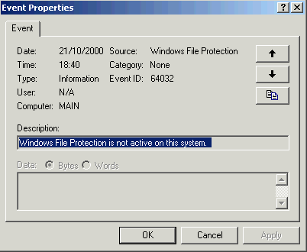
This event will be logged each time you boot Windows 2000. NOTE – Although WFP is disabled the dllcache folder will remain full of the cached files. You can/should delete the contents of this directory once WFP is disabled since they are no longer needed. Simply open your %SystemRoot%\System32\dllcache folder & delete the contents as appropriate.
11.) Memory Dumps - Windows 2000, much like previous versions of NT, will dump the contents of memory to Memory.dmp in the event of a Stop, or other fatal error. You can then use this Memory.dmp file for debugging the cause of this error. I don't find this of much use. To edit the Memory dump settings, right click on My Computer, select the Advanced tab, then the Startup and Recovery button. You should concern yourself with the settings under the Write Debugging Information heading.
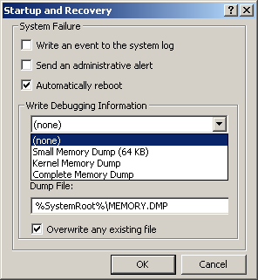
Depending on the option you select you can have No memory dump, to a Complete memory dump. If you select the Complete Memory Dump option then you will need to have set your Page File to RAM + 12MB or more. With Kernel Memory Dump you may get away with less than this.
I recommend setting it to (none) AS IT TAKES UP PAGEFILE MEMORY.
12.) Start-up Programs - Win 2K utilizes memory and programs different than Win 98/ME. There is a different protocol with initial startup and there is no Start-up (TSR) list that you can deactivate. To check out what programs truly are within the startup folder - Right-click My Computer, and choose Manage (or Start, Programs, Administrative Tools, Computer Management). In the left-hand pane of the Computer Management tool, expand System Tools, then expand System Information, then expand Software Environment. Click on Startup Programs, and a summary list programs/software will be displayed, no matter what the source of the startup is (Registry or Start Menu). There are a number of programs available to use that allow you to select what is loaded at start-up. The one use is Authoritah Boot Manger – it is free and you can get at authoritah.com
13.) Dual CPU - Windows 2000 supports multiple processors. What affect does this have on the Page File? Quite a bit - Multiple CPU’s means multiple (more) L1 & L2 cache. L1/2 cache is significantly faster than RAM & the Page File. As a result of having more of this it represents less Page File usage. If you upgrade your current system to one that has multiple CPU’s then you’ll need to do the following procedure. You will need to update the HAL (Hardware Abstraction Layer) to be able to support these extra CPU(s). Before doing so check whether or not your manufacturer offers a specific HAL update for this purpose.
1. Right click on My Computer, select Properties.
2. Click the Hardware tab, then click the Device Manager button.
3. Open Computer & then double click on the computer type and then Advanced Configuration and Power Interface (ACPI) PC.
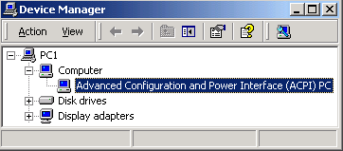
4. Select the Driver tab, then the Update Driver button. Finally, click the Next button.
5. Select Display a list of known drivers for this device, then select the Show all hardware of this device class button.
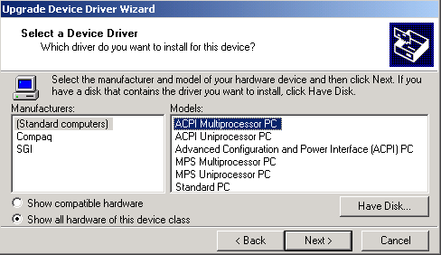

HAL | Description
ACPI Multiprocessor PC | Use for Multiprocessor ACPI systems.
ACPI Uniprocessor PC | Use for ACPI Multiprocessor board but with a single processor installed.
Advanced Configuration & Power Interface (ACPI) PC | Use for Single processor motherboard with single processor ACPI system.
MPS Uniprocessor PC | Use on non-ACPI systems dual processor motherboard with a single processor installed.
MPS Multiprocessor PC | Non-CPI systems with a dual processor running
Standard PC | Any Standard PC, non-ACPI, or non-MPS. Could be a 386, 486, Pentium, or Pentium II / III.
Compaq Systempro | Use for Compaq Systempro computers.
6. Select the Manufacturer & Model as appropriate (one that matches your current type, except for multiple CPUs), click Next, and then click Finish.
Reboot for the changes to take effect.
14.) BIOS Changes possible for RAM - RAM tweaks
RAM is a lot better performing than the Pagefile, it can help a great deal to optimize your memory settings. Restart your PC & enter the BIOS. The following settings, generally contained in the Advanced chipset features/Chip configuration section, can greatly improve memory performance and/or stability.
Bank 0/1, 2/3, 4/5 DRAM timing. Use this to set the DRAM memory module timing. Most BIOS’ default to 10ns. Other options available may be (depending on BIOS) 8ns, Normal, Medium, Fast, Turbo. Selecting a different setting may improve RAM performance, but reduce stability. Turbo is the fastest setting; 10ns is the slowest (& most stable).
DRAM Clock. With the VIA Apollo 133 based motherboards you have the option to change SDRAM speed. Settings available are Host CLK or +/-33. Host CLK allows the SDRAM to run at the same speed as the Ext. Clock (FSB). You can use the +/-33 if you want to run the RAM slower/faster than the Ext. Clock, e.g. If your Ext. Clock is 100Mhz you could use +33 to allow your SDRAM to run at 133Mhz. This is a great option for those of you with PC 133 SDRAM. Or alternatively you could run at a 133Mhz Ext. Clock while your RAM runs at 100Mhz by using the -33 setting. Or you could run PC133 RAM at 133Mhz on a 133Mhz Ext. Clock (aka FSB) by using the Host CLK option. As you can see this option allows for many possibilities.
Delay DRAM read latch. The lower the value for this the better the memory performance, although stability may be affected. Higher values may improve system stability at the cost of performance.
DRAM speculative leadoff. Enable this for better performance, although it could make your system unstable, disable it if it does.
Memory Hole At 15M-16M. Some old add-in cards need this enabled to work properly. If you have such a card then enable this, otherwise disable it.
Memory parity/ECC check/DRAM Data Integrity Mode. In the unlikely event you have ECC (Error Correcting Code) memory installed then you should set this to ECC, otherwise set it to non-ECC. Most memory is non-ECC & not really recommended for most users unless the need the added stability (some claim it is slower when ECC is being used – I use it and do not experience it being lower).
RAS active time. A high number will increase performance of the system's SDRAM. Decrease if stability is affected.
RAS to CAS delay. This should be set to a low number, although it is affected by the quality of you RAM, so set it higher if you have any difficulties afterwards.
Read around write. This is a DRAM optimization feature. If a memory read is addressed to a location whose latest write is being held in a buffer before being written to memory, the read is satisfied through the buffer contents, & the read is not sent to the DRAM. Set this to Enabled for better memory performance.
SDRAM Bank Interleave. For best memory performance set this to 4-bank/way, although lower settings may help improve stability.
SDRAM CAS Latency Time/SDRAM cycle length. This sets the CAS latency timing of the DRAM system memory access cycle when SDRAM system memory is installed. Setting this to 2 will yield better performance, although may be less stable if your SDRAM is not CAS2 rated. 3 is slower & should be used when SDRAM isn't CAS2 rated or you want to improve stability. NOTE - CAS2 can significantly improve performance in many ways.
SDRAM Precharge control. When Enabled, all CPU cycles to SDRAM result in an All Banks Precharge Command on the SDRAM interface. Setting this to Enabled should improve RAM performance. NOTE - When “overclocking”, particularly when you have an AGP graphics card that’s running at non-spec AGP bus speeds Disabling this may improve stability.

15.) USB, Parallel, Network Cards & Modem ports - Various software programs can be
integrated with USB & Parallel Port Hardware as well as Modems & Network Cards. These may inadvertently produce unnecessary polling along the PCI bus. When operating in Video Editing Mode disable your USB, Parallel Port, Network Card and/or Modem. If using a USB port mouse may consider getting standard PS/2 type. If these items are frequently needed you may set up various user bootup profiles to avoid having to go into Device Manager to enable. Leaving these active while editing can impact performance.

16.) Premiere “pref” file – On Adobe Premiere 6.0 this file is identified as Prem60 and for 5.1 it
is Prem50. These can be found in Program Files >Adobe folder > Premiere 6.0 (or 5.1). Icon has a key.
. The file is used by Premiere to hold preference settings and certain instruction code with regards to settings used, etc. Sometimes this can become corrupt and will manifest in the strangest ways (slowdowns, faulty transitions / filters, sync or poor playback, etc.). If you have problems which can not be contributed to any new hardware or software change try deleting this file. When Premiere is started (initialized) it will make a new file. However, BEWARE all of your video, drive selection settings, etc. in Premiere are now defaulted to standard Adobe settings. You will have to go back in and reset drive paths, codec settings, etc. To avoid this I make a copy of the Prem60 file once I get all my preferences set and have proven things are stable. I then save this file in a non Adobe folder. I then replace old / corrupted Prem60 folder with the spare copy – then don’t have to go back and change preferences, etc.
Here are a few ways to tell if a file is corrupted in Premiere (note not all of these are attributed to Premiere “pref” file corruption).

1.) When alt + scrubbing over the file for preview, Premiere “bombs”.
2) Audio drops out under the clip, but when the clip is removed, audio is fine.
3) A frame is repeated twice somewhere in the file. You can find it by going frame by frame.
4) There is an "error" in the timeline that causes black flashes in transitions, at the end of clips, or a frame from earlier in the timeline flashes at the end of a clip. This error can be duplicated "down the line" and effect files farther down in the timeline. Often it's hard to find the file that's causing the original error. Often times, moving a clip and then moving it back into place can temporarily fix the error. Also, sometimes it doesn't show up when you render the file to disk (as opposed to just viewing from the timeline.)

17.) Faulty RAM - There have been all kinds of stories with regards to impact of faulty RAM modules. I have seen instances where the computer seemed to function properly until editing, then all kinds of instability occurred. Later it was attributed directly to the RAM itself.
I think the following testimonial (from a recent forum post) sums it up perfectly (brand names deleted as they are not important to this exercise) :
" Here's an update about my problem (that is now solved) that might help you help other customers. When I was successfully using the "......... capture card" I kept adding ram as the prices kept coming down. I ended up with 3 sticks of 128mb PC100, and 1 stick of 256mb PC133 in the 4th slot. All worked fine. When I replaced the ".... card" with the "......capture card", all worked fine for 4 days of lots of capturing, playing and editing then all of a sudden, without me making any changes, the "......" stopped working but everything else on the system worked fine. After more than a week of pulling my hair out, replacing the motherboard, etc., etc., the problem turned out to be caused by that PC133 memory stick in my “………. Motherboard”. Even though the system worked fine with it for a considerable time, it finally started causing problem. I assumed that the memory mix was ok since the system did work ok for a time even with the new capture card. Now I can make the problem go away or come back simply by inserting that memory stick or taking it out. Lesson learned: don't mix memory no matter how sure you are you think it will work “.

18.)System Cooling
Many incidents have been reported with editing "timeline freezes"; especially after heavy work with the RT-2000 3DFLex chip. Causes have been traced to overheating and malfunction. Of course these type incidents can be avoided with extra cooling fans / systems. Some incidents have been reported to occur when fan blades on the CPU cooler get obstructed or pulled off. Most motherboards have a CPU temperature sensor right beneath the CPU socket and will shut down your system if the temperature gets too high. There are usually extra sensor connections on new motherboard designs to allow extra probes to monitor other areas and software programs that can be used to alarm.

One additional tip : Adding additional air movers is good but some people overlook the actual flow path of the air. There should be fans forcing air in on one side and on the other side oat least one drawing air out. If don't defeat the purpose and actually have poorer circulation. Some slap those suckers in not looking at air direction. Second with additional air passing through more dust is run through and accumulates. Being a chemical engineer (my real job) I can tell you that dust build up will hinder heat transfer “a lot”. Good to give cards a blast of canned air every 2 - 4 weeks (depending on usage).

Refer to Appendix Pages Below

APPENDIX I
Repair – Restoration (ERD)
To start the repair process, you should have the 1.44 MB ERD that you created in the Backup utility, and the original Windows 2000 installation CD.
If you do not have an ERD, the emergency repair process can attempt to locate your Windows 2000 installation and start repairing your system, but it may not be able to do so. Note If the emergency repair process can't fix your system, you can try using the Recovery Console or you can try reinstalling Windows 2000. See Related Topics for more information. If you are required to use your Repair Disk ; you can start your system using either the Windows 2000 Setup disks or the Windows 2000 CD. However, you can only use the CD to start your computer if your computer hardware and BIOS support this functionality.
After your computer starts, the Setup program will start. During Setup you will be asked whether you want to continue installing the Windows 2000 operating system. You must press ENTER to continue. This will start the installation process, which allows you to repair your system. During this process you can choose whether you want to install a fresh version of Windows 2000, or whether you want to repair an existing installation of Windows 2000. To repair a damaged or corrupt system, you should press R. You will then be asked whether you want to repair your system using the Recovery Console or the emergency repair process. You should press R if you want to repair your system using the emergency repair process.
- You can choose either the fast repair option, which is the easiest and doesn't require any user interaction, or you can choose the manual repair option, which requires user interaction. The fast repair option will attempt to repair problems related to the registry, system files, the partition boot sector on your boot volume, and your startup environment (if you have a dual-boot or multiple-boot system). The manual repair option lets you choose whether you want to repair system files, partition boot sector problems, or startup environment problems, but it doesn't let you repair problems with your registry. For example, using the manual repair option, you can attempt to repair only your system files if you know your partition boot sector and your startup environment are both intact. Note - The manual repair option should only be used by advanced users . The fast repair option will use a backup copy of the registry that was created when Setup was first run on your system. If you choose this option, you may lose settings or preferences you have created since Setup was first run.
- If you want to manually repair individual registry files or replace your entire registry, you can use the Recovery Console. However, this is recommended for advanced users.
To start the repair process, you should have the 1.44 MB ERD that you created in the Backup utility, and the original Windows 2000 installation CD. If you do not have an ERD, the emergency repair process can attempt to locate your Windows 2000 installation and start repairing your system, but it may not be able to do so.
Note - If the emergency repair process can't fix your system, you can try using the Recovery Console or you can try reinstalling Windows 2000. See Related Topics for more information.

APPENDIX II

Emergency Restoration procedure for Service or Registry conflict
Should you find that you inadvertently Disable a Service or registry item that is required to load Windows 2000, or for it to function correctly do the following (Assuming that the Services Utility will not load. This can occur when some Services are set to Disable or registry items conflict). If needed - Reboot and press F-8 when Windows loads. Click on Start, Run, type in regedit & hit Enter. Open the following registry key,
[HKEY_LOCAL_MACHINE\SYSTEM\CurrentControlSet\Services]. This is where the Startup type for every Service is also stored. Select the appropriate Service (If unsure check the DisplayName value in the Right hand pane) from this subfolder. In the Right hand pane there will be a DWORD value entitled Start. The value (Decimal or Hexadecimal) for this entry determines the Services Startup type, as in the previous section. To change the value Right click on the entry & select Modify. Valid values are as follows;
- A value of 2 sets the Startup type to Automatic.
- A value of 3 sets the Startup type to Manual.
- A value of 4 sets the Startup type to Disable.
This following example illustrates how you would go about restoring the Plug & Play Service from Disable to Automatic. As you can see in the [HKEY_LOCAL_MACHINE\SYSTEM\CurrentControlSet\Services\PlugPlay] key the value for Start is to 4, i.e. Disabled.
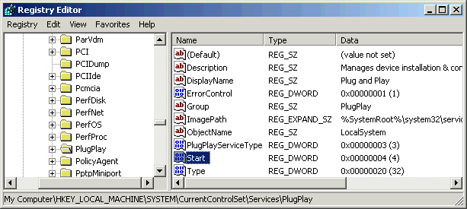
Right click on the Start entry & select Modify. Select the Value data field.
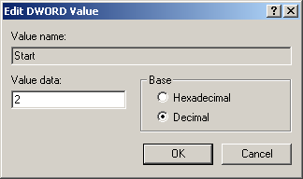
Change the value to 2 & select the OK button, this will set the Startup type to Automatic. Reboot for the change(s) to take effect. Should this fail you should resort to the ERD you should made earlier on.

APPENDIX III

How to set-up the monitoring log
To open up the System monitor (Click on Start, Control Panel, Administrative tools, Performance), Click on the Performance logs & alerts section, then RIGHT click on Counter logs. Select New Log Settings. It will ask for a new filename so give it something like test video – then hit OK. A page similar to the one below (in background partially hidden) and then select Add – a screen like the one in the foreground will appear.
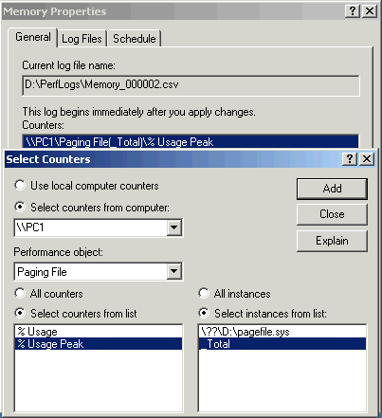
In the General tab select Add. For the Performance object, select Paging File. Select % Usage Peak & _Total respectively. I would also Click Processor and add the % usage time (& total). After select each hit Add then close Over the next few days load up System monitor & let it track your Page file size. I'd recommend saving the log as a Text file, e.g. CSV format.
It would be best to start tracking your usage when you go into editing or something that will put your PC under the highest load. Run it a few times. This will give you an idea of your Page File needs & Processor usage, however don’t go overboard with the testing you want to track normal usage, not excessive usage. The results are saved in the log file. Once you’re satisfied with your monitoring its time to consult the logs. Open your memory.csv (or whatever you saved it as) with Notepad – Excel, etc. You will see something like the display below :
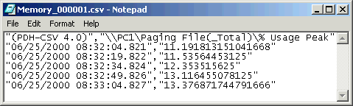
% pagingfile used

APPENDIX IV

FORUM Post about Drive Transfer problems

Why don't I see a DMA option on my disk's driver in Windows when it is connected to the Highpoint controller?
The drives connected to the Highpoint controller are seen by Windows as a SCSI device. SCSI does not support DMA and so Windows does not provide this option. However, don't worry, your disk's DMA mode is set up in the Highpoint BIOS screen - see the "Set Drive Mode" in the Menu. Providing this is correctly set, the Highpoint drivers will ensure that your disk does indeed use DMA

Maxtor DiamondMax PLUS 40gig when running at ATA-100 gives bad lockups when installed on the Highpoint Primary controller. Solution is to use the Secondary controller.

- Fixed with Highpoint BIOS 1.03b1 Under WindowsMe in the Device Manager, one of the Hard Drives attached to the Highpoint controller is not shown. It exists and can be read and written to, and there seems to be no problems with it - it just isn't shown. (Version 1.03)
- Fixed with Highpoint BIOS 1.03b1 Copying a file from a RAID-0 array to a non-RAID disk also on the Highpoint controller can cause the system to hang (Windows 2000, Version 1.03 of drivers and BIOS) (Version 1.03)
- Fixed with Highpoint BIOS 1.03b1 IBM Deskstar 75GXP drives may be incompatible with the Highpoint controller - see "Why doesn't my IBM Deskstar 75GXP drive work on the Highpoint controller?" below. (Version 1.03)
- Fixed with Highpoint BIOS 1.03b1 System would only boot from the Master disk installed on Highpoint Primary controller. (Version 1.02 and 1.03)
- Fixed with Highpoint BIOS 1.03b1 Some Maxtor disk drives are not reported as corrupted or not recognized with BIOS version 1.03 - returning to BIOS version 1.02 solves this issue. Version 1.03 of the drivers/BIOS can also cause problems with the installation of Windows2000 with Maxtor drivers - this again is solved by using version 1.02. (Version 1.03)

Why doesn't my IBM Deskstar 75GXP drive work on the Highpoint controller?
Many people have no problems with this disk. After initially posting this question I received over a dozen emails with reports of no problems with the IBM Deskstar 75GXP, and only a couple of problems. I can therefore only assume that the "timing issue" referred to above is only marginal problem and affects only a few disks. I have also received a post from a user who said that IBM support told him that this is an issue with the earlier HPT366 controller, and not the HPT370 used on the KT7-RAID.
With this in mind...
In answer to a query from one KT7-RAID user's problems with system freezes with the above disk connected to the Highpoint controller, IBM technical support responded as follows:
The issues you are having are known issues we have seen with the Highpoint chipset. The problem is a result of timing issues with the controller itself. We have seen that the drive will work properly if you were wanting to set it to the standard ATA33 slot. The only suggestions I can provide to you would be to run it on a slower controller such as the ATA 33 slot or to return the drive for a different model.
Several users say all their 75GXP problems were fixed with the new UZ103b1 BIOS and drivers.
One user who had previously been using this disk with another machine found that the computer would consistently hang at the DMI pool verify message. He eventually found the solution to this problem was to download the drive fitness utility from the IBM storage support site, and perform a full erase of the drive. After an FDISK and FORMAT, the drive booted happily from the RAID controller.
Other solutions
You could try setting the drive mode as UDMA1 or 2 in the Highpoint BIOS screen (this equates to ATA/33) - if that fails use the onboard IDE1/2 controller. Abit have also suggested increasing the FSB by 1MHz or so to try to resolve this issue, whilst Highpoint work on a BIOS or driver fix.
Several users have resolved problems using RAID with these disks by putting both disks on the Highpoint Primary IDE controller, as Master and Slave.
One user found that to solve lockups with an ATA100 IBM75GXP 45GB HDD on the Highpoint Primary controller, he had to move his CD and CDRW from the VIA Secondary to VIA Primary controller.
One user reported that setting the disks to Cable Select mode resolved lockups.

Why is my disk drive so slow, or why can't I select ATA/66 or ATA/100, on the Highpoint controller?
If your disk has a jumper or setting for enabling "Cable Select" then make sure that this is activated. This can result in a significant performance increase.
If you have removable disks, remember that the ATA/66 and ATA/100 standards require an 80-way cable to reduce cross-talk between adjacent cables. If your removable bay does not use an 80-way connection in its design, it may not support these higher speed modes.

How can I increase my disk burst speed?
It has been reported on the KT7A motherboard that with ACPI enabled under Windows 2000 the disk burst speed is considerably lower than when ACPI is disabled (20MB/s versus 80MB/s in the example quoted).
Slow disk burst speeds have been linked to problems with the network card sharing a hardware interrupt with another card. One user reported an increase in burst speed from 40MB/s to 50MB/s by resolving a conflict with his network card (see "How do I avoid IRQ conflicts?" in instabilities section). If your disk burst speed is unacceptably low, it may mean that you have a hardware IRQ conflict between two PCI devices that are not able to share hardware IRQs. Use the FAQ mentioned above to help troubleshoot this. Note, one user found that the IRQ sharing under ACPI caused his IBM DeskStar DJNA-371350 ATA-66 drive to have a burst speed of only 15MB/s under Windows 2000 , but this increased to 58MB/s when he disabled ACPI.
Significant performance increases can often be achieved by disabling the "PCI#2 Access #1 Retry" setting in the BIOS - this is enabled by default.
Try disabling unused COM ports or the LPT port to free up additional IRQs. This, particularly in a system with many PCI devices, may increase the burst speed.
Note for some CDROM's, disabling DMA support can result in a significant speed increase. One user reports an increase from around 20x speed to nearly 70x speed on his Kenwood TrueX 72 speed CDROM player when DMA is disabled.
Note that some users report a reduction in disk burst speed under Windows 2000 only with the WW and WZ BIOS versions.
One user reported that if his I/O voltage was raised above the default 3.3v then his disk's burst speed fell from 53MB/s to 28MB/s. Strange but true - apparently this problem is fixed in BIOS WZ and later.
One user found that with a CD-Writer and CDROM on their own channels as master, on IDE 1 and 2, the burst rate of the harddisk on the Highpoint Primary controller fell from 70 to 50 MB/s. This was solved by putting both the CD writer and CDROM and master/slave on IDE1

Firstly ensure that the Ultra DMA modes for each drive are set to Auto in the Integrated Peripherals section of the BIOS. However, under Windows 2000 you may need to set the Master Drive Ultra DMA setting to Disable under the IDE Controller in order for Windows 2000 to be able to enable DMA (see ABIT FAE advice).
Note that setting the disk detection to auto in the BIOS will not, in itself, enable DMA under Windows. To enable DMA it is necessary to right-click on My Computer, select Properties then the Device Manager tab. Click on the + next to Disk Drives. For each disk listed, click on Properties then Settings and then put a tick next to DMA. This can cause a very considerable increase in disk speed.
For disks connected to the Highpoint controller make sure the correct drive mode is set in the Highpoint BIOS using the Set Drive Mode option. Use UDMA5 for ATA/100, UDMA4 or UDMA3 for ATA/66 and UDMA1 or UDMA 2 for ATA/33. Use PIO for Non-DMA or Pre-DMA devices (such as older hard drives under 1GB and older CD-ROM devices). Use MW DMA for ATAPI devices such as CDROMs. You do not need to adjust any driver settings in Windows.
Some devices require a jumper to be set to enable DMA support. Others require that "cable select" be enabled on the drive. Read your device manual.
Ensure your IDE cable is connected the correct way round - blue end attached to the motherboard - otherwise you may not be able to achieve the full speed. One user found that with the cable incorrectly installed, the Secondary Master could only work at UDMA2 rather than UDMA5. Once the cable was installed correctly the drive would work at UDMA5.
Other solutions
One user emailed me to say that he could not enable DMA on his machine until he disabled SB16 emulation on his Monster Sound MX300 soundcard.
One user with an IBM Deskstar 75GXP drive on IDE1 on a KT7 (non-RAID) found that the only way to reliably get DMA to remain activated was to connect the disk to IDE2.

Why is my DiamondMax drive unstable?
Note that Maxtor recommend the use of an 80-way ATA/66 cable even with their ATA/33 drives. See the page on DiamondMax® 3400 Ultra DMA 33 drives for details.

One user running Windows98SE went into Device Manager and changed the IRQ used by the VIA Bus Master IDE Controller. DMA then worked fine.

After I enable the DMA mode for IDE drive via "Device Manager" under Windows 2000, the system reboots and the DMA mode for that drive is disabled automatically. What's going on? There isn't VIA BM Ultra ATA driver installed and the hard drive is connected to IDE channel 1 or 2. (Last Update: 04/12/2001 07:31:44)
There is a tip helps you to enable DMA mode for IDE drives by changing the setting of "Drive Ultra DMA" from default "Auto" to "Disable" in BIOS. Say, the IDE drive is on IDE-1 master,
BIOS setting -> Integrated Peripherals -> Onboard IDE-1 Controller-> Master Drive Ultra DMA -> Disable -> Save & Exit
Whenever the above setting done, Windows 2000 will enable DMA mode as your wish.

This question will no doubt grow, but to start with ...
- One user found the Adaptec 2940 SCSI controller caused system instabilities when installed in conjunction with both a 3COM 3c905 network interface card and Soundblaster Live! sound card. Replacing the Adaptec 2940 with an Adaptec 2906 solved this particular problem. [However, since first posting this one user wrote to me and said "Perhaps the user ... should have changed the order of the cards on the PCI bus: I've got the SBlive in PCI 5 and the 2940 in PCI 2, 905 in PCI 4"]
- One user experienced corrupt files with the Tekram DC-395UW SCSI card. This was solved by replacing it with a different brand of SCSI controller.

Why does Windows 2000 crash when I add a new IDE drive?
This seems to be a problem with the VIA Bus Master IDE controller installed as part of the VIA 4in1 drivers v4.26. When installing the 4in1 drivers for Windows 2000 uncheck the installation of the VIA Bus Master Ultra ATA controller. If you already have this driver installed, it is recommended that you uninstall it in and use the default Windows 2000 driver. Alternatively you may uninstall the VIA driver before adding the new drive, add the drive, then reinstall the VIA driver. See also the ABIT FAE information on this.

How can I boot off my SCSI Controller?
BIOS version YPb01 solves this problem.
Previous solutions
If you still cannot boot from your SCSI controller, use the following settings:
- Set SCSI as the boot device in the KT7 BIOS
- Disable "enable boot from SCSI CD-ROM" in the SCSI Card BIOS
- Disable support for removeable hard disks in the SCSI Card BIOS
Some users with Adaptec SCSI cards at version 2.572 have found that by flashing their SCSI BIOS to a lower version number (eg. 2.57) the problem is solved.
Failing the above, many users find that if they flash their motherboard BIOS to version UL then it is possible to boot from their SCSI disk without difficulties. Do not attempt this with a KT7A or KT7A-RAID board, as these boards are only supported with BIOS WW and later.

Why does my machine crash with a disk on IDE2 and a Soundblaster card?
It has been reported that on machines with the KT133A chipset (the KT7A and KT7A-RAID), a Soundblaster card, and a disk connected to the VIA IDE Secondary controller, the machine will hang when large amounts of data are transferred to or from the disk. The solution to this problem appears to be either to replace your sound card (!) or to install the VIA bus mastering driver separately and choose the miniport option (this is not available when installed from the 4in1 package). These are available here. Another user found that disabling "Enhance chip performance" in SoftMenu III solved the problem

Why doesn't my IBM Deskstar 75GXP drive work on the Highpoint controller?
Many people have no problems with this disk. After initially posting this question I received over a dozen emails with reports of no problems with the IBM Deskstar 75GXP, and only a couple of problems. I can therefore only assume that the "timing issue" referred to above is only marginal problem and affects only a few disks. I have also received a post from a user who said that IBM support told him that this is an issue with the earlier HPT366 controller, and not the HPT370 used on the KT7-RAID.
With this in mind...
In answer to a query from one KT7-RAID user's problems with system freezes with the above disk connected to the Highpoint controller, IBM technical support responded as follows:
The issues you are having are known issues we have seen with the Highpoint chipset. The problem is a result of timing issues with the controller itself. We have seen that the drive will work properly if you were wanting to set it to the standard ATA33 slot. The only suggestions I can provide to you would be to run it on a slower controller such as the ATA 33 slot or to return the drive for a different model.
Several users say all their 75GXP problems were fixed with the new UZ103b1 BIOS and drivers.
One user who had previously been using this disk with another machine found that the computer would consistently hang at the DMI pool verify message. He eventually found the solution to this problem was to download the drive fitness utility from the IBM storage support site, and perform a full erase of the drive. After an FDISK and FORMAT, the drive booted happily from the RAID controller.
Other solutions
You could try setting the drive mode as UDMA1 or 2 in the Highpoint BIOS screen (this equates to ATA/33) - if that fails use the onboard IDE1/2 controller. Abit have also suggested increasing the FSB by 1MHz or so to try to resolve this issue, whilst Highpoint work on a BIOS or driver fix.
Several users have resolved problems using RAID with these disks by putting both disks on the Highpoint Primary IDE controller, as Master and Slave.
One user found that to solve lockups with an ATA100 IBM75GXP 45GB HDD on the Highpoint Primary controller, he had to move his CD and CDRW from the VIA Secondary to VIA Primary controller.
One user reported that setting the disks to Cable Select mode resolved lockups.

How do I move my bootable disk onto the HPT370 controller under Windows?
This will not enable RAID, but simply move the disk onto the Highpoint controller. Do the following:
- Install latest KT7-RAID BIOS and note Highpoint BIOS version from documentation
- With bootable disk on KT133 controller enable Future ATA in the BIOS
- Install Highpoint driver version corresponding to Highpoint BIOS version
- Reboot when asked, then shutdown
- Move disk to Highpoint controller
- Set FutureATA as boot device in the BIOS

Why can't I boot from the Highpoint controller when a SCSI card is installed?
One user wrote to me, "If you have a SCSI controller that supports bootable SCSI HDs, like a 2940, you need to disable the BIOS if you want to boot to the Highpoint and still use the SCSI drives. For some reason, the Highpoint does not reserve drive C: for the array after it initalizes. If you leave the SCSI BIOS enabled, the SCSI controller assigns the first HD letter C: and the computer will try to boot to it, ignoring the array. If you disable the SCSI BIOS, the computer recognizes the array and boots normally. Win9x will them recognize the SCSI devices and assign them drive letters so they are usable. I tried disabling the int13h bios extensions to prevent the SCSI controller from assigning C: and trying to use it as a boot device, but it did not work. The only thing that worked was disabling the SCSI BIOS completely.". Other users have since verified this problem and that disabling the SCSI BIOS solves it.
Another user wrote that he was able to boot without disabling the SCSI BIOS providing he moved his CDROM device onto the secondary VIA IDE controller. He had no devices on the primary VIA IDE controller.

FYI: You may not observe any disk access improvement (and you do NOT need to alter your Registry) with some UltraDMA66 controllers, like the ones manufactured by Promise Technology, because these have the DMA setting enabled by default into the drivers. [Thank you Bob DeYoung (am_dew@primenet.com)!]
I'm not going here into details about the meaning of UDMA66, ATA/66 and SCSI, because it is not the purpose of this article. ;)
I have tested and am using successfully this Registry workaround ONLY on my High Point Technologies UDMA66 IDE hard disk controller (model HPT366) built into my Abit BE6-II Pentium II/III Slot 1 PCI/AGP motherboard.
The HPT366 updated drivers [v1.25, current as of 4-19-2000] for Windows 95/98 can be downloaded from the High Point Tech, and the Abit [v1.25 driver, current as of 6-2-2000] support web pages (free).
Also, all BE6-II AWARD BIOS (flash) updates begining with release UH [175 KB, free, 8-16-2000] include the current BIOS update (v1.25) for the HPT366 controller.
So far so good. But what I didn't quite like is that after properly installing the HPT366 drivers (any version!) in Windows 98 SE, the DMA option, usually available for all (E)IDE drives (hard disks, CD-ROMs, CD-Rs, CD-RWs, DVDs etc) connected to the standard motherboard (E)IDE controller (NOT add-on!), which can be enabled in: Control Panel -> System -> Device Manager tab -> Disk drives (or CDROM) -> Your "Drive Name + Model Number" here -> Settings tab -> DMA toggle check box, was NOT present!
Not a problem though. I've found a simple way [read Registry tweak :)] to bring back the DMA setting for both my IBM Deskstar 22GXP UDMA66 (22 GB) EIDE hard drives, hooked up to the HPT366 ATA/66 controller.
Fire up Regedit and go to the add-on disk controller Registry key(s), in this case the HPT366 "SCSIAdapter" key(s):
HKEY_LOCAL_MACHINE\System\CurrentControlSet\Services\Class\SCSIAdapter\0001
and:
HKEY_LOCAL_MACHINE\System\CurrentControlSet\Services\Class\SCSIAdapter\0002
which MUST show the respective adapter name on the "DriverDesc" String Value, in this case: "Highpoint Technology Inc. HPT366 Ultra DMA 66 Controller".
There are two keys here because I have two UDMA66 EIDE hard drives connected to my add-on adapter. You might have only one key if using only one drive [jumpered as master, of course :)].
In the right hand pane of both keys above: right-click -> select New -> Binary Value -> name it "IDEDMADRIVE0" (don't type the quotes) -> click OK -> double-click on it -> type 01 -> click OK. This will enable the DMA box on the master (single or primary in 2 drives setup) hard drive. I have two, so I created another Binary Value (by performing same steps) named "IDEDMADRIVE1" (secondary or slave in 2 drives setup), and I gave it the same value: 01.
Then you need to point Regedit to the HKLM\Enum\PCI\ and HKEY_LOCAL_MACHINE\Enum\SCSI\ keys that contain the "incriminated" add-on bus adapter and disk subsystem registered vendor serial numbers (refering here to the same example above):
HKEY_LOCAL_MACHINE\Enum\PCI\VEN_1103&DEV_0004&SUBSYS_00000000&REV_01\BUS_00&DEV_13&FUNC_01
and respectively:
HKEY_LOCAL_MACHINE\Enum\SCSI\IBM-DJNA-372200_________J\PCI&VEN_1103&DEV_0004&SUBSYS_00000000&REV_01&BUS_00&DEV_13&FUNC_0000
it MUST show the respective adapter name on the "DeviceDesc" String Value, in this case: "Highpoint Technology Inc. HPT366 Ultra DMA 66 Controller".
In the right hand pane: right-click -> select New -> Binary Value -> name it "DMACurrentlyUsed" (don't type the quotes) -> click OK -> double-click on it -> type 01 -> click OK.
Close Regedit when done and restart Windows.
Now go to: Control Panel -> System -> Device Manager tab -> Disk drives -> Your "Drive Name + Model Number" here -> Settings tab -> DMA box -> left-click it once to place a checkmark in it -> click OK/Apply twice. Repeat these steps for ALL your drives connected to the add-on adapter -> reboot your system when prompted.
Voila!

APPENDIX V

Windows 2000 settings available via the registry to optimise speed
Click on Start, Run. Type in regedit & hit Enter. Go to [HKEY_LOCAL_MACHINE\SYSTEM\CurrentControlSet\Control\Session Manager\Memory Management]. You may add/edit the following entries listed below as you see fit. Some of these settings were obtained via various MS Knowledge Base articles.
ClearPageFileAtShutdown. This is a security related setting. Using this DWORD value you can "clear" the contents of the Page File when shutting down the machine. Right click on the entry & select Modify. A value of 1 enables this feature, 0 disables this. I'd recommend leaving this set to 0 unless you are truly highly security conscious. Performance is not affected, although shutting down will take longer as a result.
LargeSystemCache. Using this DWORD value you can specify that the system favour the system-cache working set rather than the processes working set. This allows Windows 2000 to use RAM – 4MB for disk caching purposes. The 4MB free is used for faster launching of new applications. By default in Windows 2000 Professional this is disabled, although in the Server version it is enabled by default. Right click on the entry & select Modify. A value of 1 enables the LargeSystemCache, 0 disables it. If you have a lot of RAM enabling this will be of great benefit to performance.
NonPagedPoolSize. This DWORD value specifies the size of the Non-paged pool in bytes. When this value is 0, the system uses the default size (based on RAM). The maximum value is about 80 percent of physical memory. I would recommend leaving this at 0, so Windows 2000 can determine the size.

PagingFiles. This BINARY value contains the settings that you have set in Virtual Memory. It is however useful in that you may change the name of the Page File with this entry. Still, if you are dual booting with Windows 9x it is infinitely easier to rename the Win9x swapfile, rather than the Windows 2000 one.
SecondLevelDataCache. Using this DWORD value you can specify the amount of L2 cache you have in your machine. SecondLevelDataCache records the size of the processor cache, also known as the secondary or L2 cache. If the value of this entry is 0, the system attempts to retrieve the L2 cache size from the Hardware Abstraction Layer (HAL) for the platform. If it fails, it uses a default L2 cache size of 256KB. If the value of this entry is not 0, it uses this value as the L2 cache size. Right click on the entry & select Modify. Select the Decimal button & enter in the amount (in KB's) of L2 cache you have in your system. This can be quite useful with some CPU's, e.g. Pentium 3's can have either 512 or 256KB of L2 cache, depending on the model you have. It's also useful in that no time need be wasted determining the amount of L2 in your system.

APPENDIX VI
Services list & Recommendation Settings
Depending on your Windows 2000 installation, some of the Services listed below, may, or may not appear. This can be caused by the Installing/Uninstalling certain Networking Components, such as File & Printer Sharing for Microsoft Networks or Client for Microsoft Networks, and/or other Hardware & Programs.
Now the Services – One-by-One :
Alerter. Notifies selected users & computers of administrative alerts. Set to Manual if you aren't connected to a network. If you are connected to a network set it to Automatic, this will enable your System Administrator to be informed when something goes wrong in your system, which may aid them in Diagnosing, & fixing the issue.
Application Management. Provides software installation services such as Assign, Publish, & Remove. Leave this set to Manual.
ClipBook. Supports ClipBook Viewer, which allows pages to be seen by remote ClipBooks. Set this to Manual to enable users to be able to view information on the Clipbook server. You shouldn't ever need to set this to Automatic.
COM+ Event System. Provides automatic distribution of events to subscribing COM components. Set this to Automatic.
Computer Browser. Maintains an up-to-date list of computers on your network & supplies the list to programs that request it. Set this to Manual if you aren't connected to a network. If you are connected to a network set it to Automatic as it will enable you to browse through My Network Places & such.
Creative Service for CDROM Access. This service is added during installation of Creative Livewire for SoundBlaster Live! Audio cards. If you enabled the use of the Disc Detector utility then you should set this to Automatic, otherwise leave it set to Manual.
DHCP Client. Manages network configuration by registering & updating IP addresses & DNS names. If you on a network or have a permanent internet connection, connected to a specified DCHP server set this to Automatic. Those who are not connected to a network (or specific DCHP server) set this to Manual. Should you have problems connecting to websites & such after setting DCHP Client to Manual then do the following :.
- Click on Start, Settings, Control Panel, Network & Dial-up Connections.
- Highlight your connection & Right click on it, selecting Properties. Then hit the Networking tab.
- Highlight Internet Protocol (TCP/IP) & select the Properties button, then hit the Advanced button. Select the DNS tab.
- In this tab Untick Append parent suffixes of the primary DNS suffix & Register this connection’s addresses in DNS, as shown in the picture below.
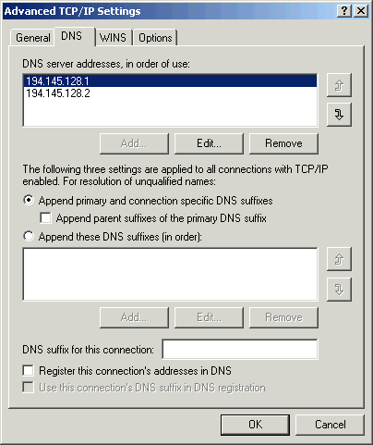
- Click Ok 3 times to exit Network & Dial-up Connections. You will need to restart your machine (disconnect at least) in order for these changes to take effect.
Distributed Link Tracking Client. Sends notifications of files moving between NTFS volumes in a network domain. Set this to Manual. It is unlikely you will use this particular Service. If however you are connected to a Windows 2000 domain & use the NTFS file system, set it to Automatic.
Distributed Transaction Coordinator. Coordinates transactions that are distributed across two or more databases, message queues, file systems, or other transaction protected resource managers. Leave this set to Manual.
DNS Client. Resolves & caches Domain Name System (DNS) names. Set this to Automatic if you are connecting to a specific DNS server on a network (You can verify this in the Network & Dial-up Connections folder, viewing the Properties for your Network connection). Otherwise set it to Manual.
Event Log. Logs event messages issued by programs & Windows. Event Log reports contain information that can be useful in diagnosing problems. Reports are viewed in Event Viewer. Leave this set to Automatic, this will allow you to log errors & such in programs & is needed to track certain other activities, such as Performance logs.
Fax Service. Helps you send & receive faxes. This Service is added if you have installed a Fax capable Modem in machine. If you have no intention of using the Modems Fax capabilities however, you should set this to Manual. If you intend to use the Modems Fax capabilities a lot then set this to Automatic.
FTP Publishing Service. Provides FTP connectivity & administration through the Internet Information Services snap-in. If you have IIS 5.0 installed, & is configured to provide an FTP on your machine set this to Automatic, otherwise leave it set to Manual.
IIS Admin Service. Allows administration of Web & FTP services through the Internet Information Services snap-in. If you have IIS 5.0 installed & configured to provide an FTP/Website on your machine set this to Manual to allow you to configure it whenever needed.
Indexing Service. Indexes contents & properties of files on local & remote computers; provides rapid access to files through flexible querying language. This Service is added if you the Indexing Service installed (It is installed by default). The Indexing service is similar to FindFast in Microsoft Office, although is generally regarded as more useful. Most should be fine leaving this set to Manual. Although if you wish to maintain regular index updates set this to Automatic.
Internet Connection Sharing. Provides network address translation, addressing, & name resolution services for all computers on your home network through a dial-up connection. If you are sharing an Internet connection on your network then set this to Automatic. If no Internet connection is being shared you can set this to Manual.
IPSEC Policy Agent. Manages IP security policy & starts the ISAKMP/Oakley (IKE) & the IP security driver. If you aren't connected to a Windows 2000 Domain you may set this to Manual. If you are connected to a Windows 2000 Domain set this to Automatic.
Logical Disk Manager. Logical Disk Manager Watchdog Service. Set this to Automatic.
Logical Disk Manager Administrative Service. Administrative service for disk management requests. This Service may be set to Manual.
Messenger. Sends & receives messages transmitted by administrators or by the Alerter service. If you are connected to a Windows 2000 Domain/Network set this to Automatic. If you aren't connected to a network you may set this to Manual.
Net Logon. Supports pass-through authentication of account logon events for computers in a domain. If you are connected to a Windows 2000 Domain then set this to Automatic. If you aren't connected to a Windows 2000 Domain you may set it to Manual.
NetMeeting Remote Desktop Sharing. Allows authorized people to remotely access your Windows desktop using NetMeeting. For security reasons I'd recommend you set this to Disable unless you really need to give others remote access to your Desktop via NetMeeting, in this case set this Service to Manual.
Network Connections. Manages objects in the Network & Dial-Up Connections folder, in which you can view both local area network & remote connections. Leave this set to Automatic unless your system is not connected to a Network/Internet, in which case you may set this to Manual.
Network DDE. Provides network transport & security for Dynamic Data Exchange. Set this to Automatic if you use DDE connections (you won't need this unless you are using certain legacy applications). DDE is a type of IPC (InterProcess Communication). If you need this you generally should know that. Otherwise, set this to Manual. Supports network transport of DDE (Dynamic Data Exchange) connections.
Network DDE DSDM. Manages shared dynamic data exchange & is used by Network DDE. Set this to Automatic if you have set the Network DDE Service to Automatic. Otherwise, set it to Manual.
NT LM Security Support Provider. Provides security to Remote Procedure Call programs that use transports other than named pipes. For improved security with RPC Applications you should set this to Automatic. If you don't use many of these you may save some Memory by setting this to Manual.
Performance Logs & Alerts. Configures performance logs & alerts. If you have your system configured to track events/system performance, etc. upon system startup set this to Automatic. If your system isn't configured like this leave it set to Manual.
Plug & Play. Manages device installation & configuration & notifies programs of device changes. Set this to Automatic. It will make hardware installation far easier.
Print Spooler. Loads files to memory for later printing. If you don't have a Printer installed (Network, or local) you can set this to Manual. If you have a printer installed, or intend to install a printer then set this to Automatic. You can read more in this MS Knowledge Base articles.
Protected Storage. Provides protected storage for data, such as private keys, to prevent access by unauthorized services, processes, or users. If your system contains such sensitive data then you should set this to Automatic (to keep it protected at all time). When set to Manual you may find this causes problems with certain programs, e.g. Outlook Express or Internet Explorer's “Autocomplete” feature, if so then set this back to Automatic.
QoS RSVP. Provides network signaling & local traffic control setup functionality for QoS-aware programs & control applets. Leave this set to Manual, most users will not be using such programs & have no need to set it to Automatic. If you don’t know what this is you don’t need it.
Remote Access Auto Connection Manager. Creates a connection to a remote network whenever a program references a remote DNS or NetBIOS name or address. In most instances you should be able to set this to Manual without any issue. Although if you are using a modem to provide Internet connectivity it is recommended you set this to Automatic (I don’t think this is necessary).
Remote Access Connection Manager. Creates a network connection. Leave this set to Automatic if you are connecting to a network. Those not connected to a network should be able to set this to Manual.
Remote Procedure Call (RPC). Provides the endpoint mapper & other miscellaneous RPC services. Set this Service to Automatic. Setting it to Manual/Disable can cause trouble, it can stop any Internet activity from occurring.
Remote Procedure Call (RPC) Locator. Manages the RPC name service database. Much like the Remote Procedure Call (RPC) Service above you should also leave this set to Automatic if available.
Remote Registry Service. Allows remote registry manipulation. You should set this to Disable unless the Network administrator needs to be able to enter each PC's registry remotely, in which case a setting of Automatic would be more appropriate. Selecting Disable is also a useful security feature in case a unwanted user manages to obtain the Administrator's password & intends to remotely perform harmful acts to the systems registry.
Removable Storage. Manages removable media, drives, & libraries. If you have such devices, e.g. Tape drives (not CD\DVD\Floppy drives), then this set to Automatic. Otherwise you may leave it on Manual. NOTE – If set to Manual you will need to Start this service before using the Backup program with such backup devices.
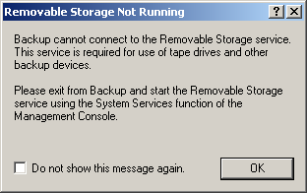
Routing & Remote Access. This Offers routing services to businesses in local area & wide area network environments. If that description fits your system/network type then set this to Automatic, otherwise leave it set it to Manual.
RunAs Service. This enables starting processes under alternate credentials. You should set this to Manual, this can allow you to use “WindowsUpdate” when logged on as a user other than the Administrator (many updates require you to be logged on as an Administrator to install).
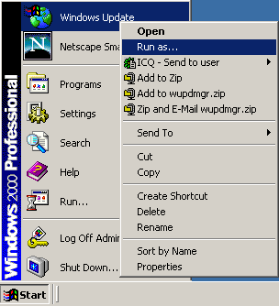
For example, to use the RunAs service with WinUpdte - Click on Start, hold down the Shift key, Right click on WindowsUpdate & click RunAs, then Run the program as BACKUP/Administrator. For security purposes you would be best advised to set this to Disable, particularly on systems which are accessed by multiple users & you don't want the risk of them guessing an Users password with Administrative privileges necessary to perform certain tasks.
Security Accounts Manager. Stores security information for local user accounts. Leave this set to Manual if you haven't changed any Security policies via the Local Security Policy editor. If you have made Security Policy change set this to Automatic in order that the policies may be applied at User logon.
Server. Provides RPC support & file, print, & named pipe sharing. If you have IIS 5.0 installed & active on your machine it is recommended that you set this to Manual. Set this to Automatic should you wish to make Offline files available to others – this is valid if their machines support SMB (Server Message Block-based) File & Printer Sharing.
Simple Mail Transport Protocol (SMTP). Transports electronic mail across the network. You should leave it set to Manual.
Smart Card. Manages & controls access to a smart card inserted into a smart card reader attached to the computer. If you use a SmartCard (not likely) then you can set this to Disabled or Manual. Of course if you do happen to use a smart card system set this to Automatic.
Smart Card Helper. Provides support for legacy smart card readers attached to the computer. If you use a SmartCard (again not likely) then you can set this to Disabled or Manual. If you do happen to use a smart card system set this to Automatic.
System Event Notification. Tracks system events such as Windows logon, network, & power events. Notifies COM+ Event System subscribers of these events. I'd recommend leaving this set to Manual, or Automatic depending on how your system is configured (particularly if on a network). You can leave this set to Manual without any problems.
Task Scheduler. Enables a program to run at a designated time. Much like Task Scheduler in Windows 98 this can be used to schedule certain programs be to run at specified times & such. I would leave this set to Disabled & run the programs myself - if you need to have task to schedule then set it to Automatic.
TCP/IP NetBIOS Helper Service. Enables support for NetBIOS over TCP/IP (NetBT) service & NetBIOS name resolution. If your Internet connection is setup to enable LMHOSTS Lookup then set this to Automatic. Otherwise set this to Manual.
Telephony. Provides Telephony API (TAPI) support for programs that control telephony devices & IP based voice connections on the local computer &, through the LAN, on servers that are also running the service. Leave this set to Automatic, generally this Service is started when you load Windows 2000 even when set to Manual.
Telnet. Allows a remote user to log on to the system & run console programs using the command line. In the event that you still use Telnet ,or wish to enable others to (Locally or remotely) access your system via Telnet set this to Automatic. Otherwise set to Disable it will improve system security as well.
Uninterruptible Power Supply. Manages an uninterruptible power supply (UPS) connected to the computer. If you are connected to such a power supply leave this set to Automatic, otherwise leave in Manual.
Utility Manager. Starts & configures accessibility tools. If you don't use (or have Uninstalled) the Accessibilty Tools in Windows 2000 you should set this to Disabled/Manual. If you use Accessibility Tools set this to Automatic.
WMDM PMSP Service. This Service is added during installation of Windows Media Player 7. Seemingly this Service deals with the Windows Media Device Manager – WMDM. I have found setting this to Manual causes no noticeable effects in Windows Media Player 7.
Windows Installer. Installs, repairs & removes software according to instructions contained in .MSI files. Leave this set to Manual. This will allow you to Install/Uninstall/Repair programs listed in the Add/Remove Programs applet in the Control Panel. You should set this to Disable if you don't wish others to have the ability to change any software installation, or to install Programs/Hardware which use the Windows Installer.
Windows Management Instrumentation. Provides system management information. WMI is a management infrastructure in Windows 2000 that supports monitoring & controlling system resources through a common set of interfaces & provides a logically organized, consistent model of Windows operation, configuration, & status. Leave this set to Automatic.

Windows Management Instrumentation Driver Extensions. Provides systems management information to & from drivers. This should be set to Automatic as it seemingly gets Started even if you set it to Manual. Setting it to Disable (attempting to Stop the service) will display the following error window.
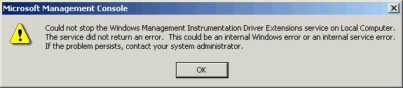
Windows Time. Sets the computer clock. You may leave this Service set to Manual.
Workstation. Provides network connections & communications. Should you have the Alerter or Messenger Services set to Automatic then set this to Automatic also. Otherwise you should be able to safely set this to Manual instead.
World Wide Web Publishing Service. Provides Web connectivity & administration through the Internet Information Services snap-in. If you have IIS 5.0 installed, & is configured to provide a Website on your machine set this to Automatic, otherwise leave it set to Manual.
Should you find that any of the Services you have attempted setting to Manual are actually Started when Windows 2000 is re-laoded you should set them to Automatic instead. You may verify this by checking the Status tab in the Services Utility in Administrative Tools.

NOW re-boot and check Task Manager again for differences and to verify system will re-load without conflicts, etc.

